**0**

**Smart Interior Design**

**Graduation project**

**PREPARED BY:**

|  |  |  |
| --- | --- | --- |
| **No.** | **Student Name** | **Student ID** |
| 1 | Andrew Osama Yacoub | 20-00665 |
| 2 | Mahmoud Abdelwahed Mahmoud | 20-00493 |
| 3 | Farah Mostafa Nagaty | 20-00631 |
| 4 | Elarya Sameh Ageeb | 20-00469 |
| 5 | Arwa Ahmed Abdelaziz | 20-00875 |
| 6 | Abeer Anwar Mohamed | 20-00462 |
| 7 | Menna Mamdouh Adly | 20-00590 |

**SUPERVISORS**

**Dr. Khaled Wasef**

Professor of Artificial Intelligence

at Cairo University

**Eng. Mohamed Gamal**

Teaching Assistant, IT Department at Egyptian E-Learning University

A Graduation Project Report Submitted for the Partial Fulfillment of the Requirements of the B.SC. Degree

**Assiut 2023 - 2024**

**Acknowledgement**

We would like to express our heartfelt gratitude and appreciation to all those who have contributed to the successful completion of our graduation project in the Faculty of Computer & Information Technology at the Egyptian E-Learning University.

First and foremost, we extend our deepest appreciation to **Dr.Khaled Wasef**, our esteemed project supervisor and a distinguished professor at Cairo University. His guidance, expertise, and unwavering support were instrumental in shaping our project and enabling us to overcome challenges along the way. We are truly grateful for his invaluable insights, patience, and dedication to our academic growth.

We would also like to extend our sincere thanks to **Eng. Mohamed Gamal**, our dedicated Assistant Lecturer at the Egyptian E-Learning University. His expertise, constructive feedback, and guidance throughout the project have been immensely valuable. His continuous encouragement and commitment to our development have played a significant role in our project's success.

Furthermore, we would like to express our gratitude to the Faculty of Computer & Information Technology at the Egyptian E-Learning University for providing us with an excellent educational environment and the necessary resources to pursue our graduation project. The faculty's commitment to academic excellence and its emphasis on practical learning have greatly enhanced our educational journey.

Lastly, we would like to acknowledge our families for their unwavering support, understanding, and encouragement throughout our academic journey. Their love, patience, and belief in our abilities have been the driving force behind our achievements.

Thank you all sincerely

**Abstract**

Smart Interior Design revolutionizes traditional living spaces by seamlessly integrating cutting-edge technologies to enhance comfort, convenience, and sustainability. This abstract explores the transformative potential of Smart Interior Design, offering insights into its principles, applications, and benefits.

Smart Interior Design encompasses the thoughtful integration of smart home technologies, innovative materials, and sustainable design principles to create harmonious and efficient living environments. By leveraging automation, connectivity, and intelligent systems, Smart Interior Design optimizes space utilization, enhances energy efficiency, and fosters a more connected lifestyle.

Key components of Smart Interior Design include smart lighting systems that adapt to natural light and user preferences, automated climate control solutions that optimize comfort and energy usage, and intuitive home automation platforms that enable seamless control of various devices and systems.

Moreover, Smart Interior Design embraces the use of eco-friendly materials, energy-efficient appliances, and sustainable building practices to minimize environmental impact and promote long-term sustainability.

Through case studies, design guidelines, and practical recommendations, this abstract highlights the transformative potential of Smart Interior Design in enhancing the way we live, work, and interact with our surroundings. It underscores the importance of embracing innovation, creativity, and sustainability to create living spaces that are not only aesthetically pleasing but also intelligent, responsive, and adaptable to the evolving needs of occupants.

Table of Contents

Chapter 1 1

Introduction 1

1.1. History 1

1.1. Background 3

1.2. Related work 4

1.3.1. Room Planner: Home Interior 3D: 4

1.3.2. Home By Me 5

1.3.3. Interior Design: 6

1.3.4. Cost & Resource Optimization: 7

1.4. Problem statement 8

1.4.1. High Time and Effort 8

1.4.2. Costly Mistakes 8

1.4.3. Limited Visualization 8

1.5. Problem solution 9

1.5.1. Endless Design Catalog 9

1.5.2. 3D Rendering & Virtual Tours 9

1.5.3. Automated Material Selection 9

1.5.4. Cost & Resource Optimization 9

1.6. Project Phases 9

Chapter 2 9

Frontend 10

2.1. Prototype: 10

2.1.1. improving the final form: 12

2.1.2.the language we use on the website : 15

2.1.3.login to the website 22

2.1.4. Home page 26

2.1.5.CSS Code 41

2.1.6. JavaScript Code 43

Chapter 3 44

Machine Learning 44

3.1. Introduction and Installation Process 44

3.1.1. Introduction 44

3.2. Installation Process 44

3.2.1. Installing Dependencies: 44

3.2.2.Downloading Additional Dependencies: 44

3.3.3. Setting Environment Variables: 44

3.2. Package Installation and Setup 45

3.2.1. Package Installation 45

3.2.2. Environment Setup 45

3.3. Code Imports and Initializations 46

3.3.1. Code Imports 46

3.3.2. Initialization 47

3.4. Dependency Installation 48

3.4.1. Package Installation (Continued) 48

3.4.2. Downloading Dependencies 48

3.5. Cleanup and Finalization 48

3.5.1. Cleanup 48

3.6. Completion Message 48

3.6.1. Completion Message 49

3.7. Model Download and Setup 49

3.7.1. Model Download 49

3.7.2. Model Setup 49

3.8. Finalization and Verification 51

3.8.1. Finalization 51

3.9. Variable Declaration and Session Initialization 51

3.9.1. Variable Declaration 51

3.9.2. Session Initialization 52

3.10. Instance and Concept Images Setup 52

3.10.1. Instance and Concept Images 52

3.11. Model Loading and Setup 52

3.11.1. Model Loading 52

3.12. Instance Image Upload and Preprocessing 53

3.12.1. Instance Image Upload 53

3.13.Training the model 53

3.13.1Overview 53

3.13.2. Setup Instructions 53

3.13.3. Parameters 54

3.14. Key Functions 55

3.14.1. Parameters F1: 55

3.14.2. Parameters F2: 56

3.15. Model Output 57

3.15.1. Bathroom 57

3.15.2. Bedroom 58

3.15.3. Dining Room 59

3.15.4. Kitchen 60

3.15.5. Lining Room 61

3.16.Ai Page Contant 62

3.16.1.Top Section 62

3.16.2.Main Tabs 62

3.16.3.Prompt Area 63

3.16.4.Generation Settings 63

3.16.5.Additional Controls 64

3.16.6.Bottom Section 65

Chapter 4 66

Create Room “3D” 66

4.1. Vite & Three.js in Our Project 66

4.1.1. Why using Vite 66

4.1.2. Why Choose Three.js for Our Project 66

4.2. Imports 68

4.2.1.Three.js Core 69

4.2.2. OrbitControls 69

4.2.3. Sky Shader 70

4.2.4. GLTFLoader 70

4.2.5. DragControls 70

4.2.6. TransformControls 70

4.2.7. Items Module 71

4.3. Toggle dark mode 71

4.3.1. Detailed Explanation 72

4.3.2. Key Components 72

4.3.3. Flow of Execution 72

4.4. 2D view 72

4.4.1. Canvas and its drawing context 72

4.4.2. Core Components 73

4.4.3. Usage 74

4.5. 3D view 75

4.5.1. Detailed Setup Functions 76

4.5.2. Animation and Interaction 78

4.5.3. Key Components and Concepts 80

4.5.4. Put walls and update 3D view 80

4.5.5. Load furniture objects and put transformControls 82

4.5.6. Transform Controls 85

4.5.7. Drag Controls 87

4.6. Buttons 88

4.6.1. 2D and 3D View Toggle Buttons 88

4.6.2. 2D View Button 89

4.6.3. 3D View Button 89

4.6.4. Reset Camera Button 89

4.6.5. Clear All Shapes Button 89

4.6.6. Clear All Furniture Button 90

4.6.7. New One Button 90

4.6.8. Toggle Controls Button 91

4.6.9. Save Functionality 91

4.6.10. Load Functionality 91

Chapter 5 93

Backend 93

5.1. Why PHP is Choice in our project? 93

5.1.1. Web-Centric Development: 93

5.1.2. Wide Adoption and Support: 93

5.1.3. Content Management Systems: 93

5.1.4. Cost-Effective Hosting: 93

5.1.5. Database Integration: 94

5.1.6. Frameworks: 94

5.2. Connection between database and php 95

5.2.1. Choose a Database 95

5.2.2. Set Up the Database 95

5.2.3. Connect to the Database 95

5.3. Create the Users Table 96

5.3.1.Ensure table in your database to store the user data. 96

5.3.2. structure of table 96

5.3.3.ER Schema 97

5.4 Form Handling Script: 98

5.4.1Handle Form Submission: 99

5.4.2.Load Composer's autoloader: 99

5.4.3.Download PHPMailer 99

5.4.4. Generate forget Password 99

Chapter 6 103

References 103

# Chapter 1

# Introduction

AI technology is revolutionizing the interior design industry, bringing efficiency and creativity to the traditional design process.

Our AI Interior Design Website leverages cutting-edge technology to enhance the experience for both designers and homeowners.

Creative Assistance: we strive to provide users with AI-powered tools that assist in generating innovative and unique design ideas.

Inspiration & Visualization: our platform enables users to easily visualize and explore different interior design styles and ideas.

Virtual Reality Experience: Immerse yourself in virtual spaces to experience the design firsthand before the physical implementation.

Stay Up to Date: We keep you informed about the latest interior design trends.

For many reasons, we choose this project:

* Lack of inspiration in having a suitable design.
* Difficulty visualizing what the design will look like before implementing it.
* Costly and time-consuming errors.
* Increase in the prices of interior engineers.

## History

The use of 3D design in interior design dates back to the late 20th century with the emergence of Computer-Aided Design (CAD) software. Designers began utilizing these tools to create virtual models of interior spaces, enabling them to visualize and manipulate designs in three dimensions.

The concept of smart homes gained traction in the early 21st century with the proliferation of internet-connected devices. These technologies allow homeowners to control various aspects of their home environment remotely, such as lighting, temperature, security systems, and entertainment systems, through smartphone apps or voice commands.

Machine learning algorithms started to be integrated into smart home systems to enhance automation and personalization. These algorithms analyze user behavior and preferences to anticipate their needs and adjust the home environment accordingly. For example, a smart thermostat might learn the occupants' schedule and temperature preferences to optimize energy usage and comfort.

As computing power increased and software capabilities improved, 3D rendering became more sophisticated, allowing for highly realistic virtual representations of interior spaces. VR technology further enhanced the design process by enabling clients to virtually "walk through" and experience proposed designs before any physical changes were made to their homes.

Machine learning algorithms have been applied to optimize interior design processes. For example, they can analyze large datasets of design trends, user preferences, and spatial constraints to generate design recommendations or automatically generate layout options that maximize functionality and aesthetics.

Machine learning algorithms are used to provide personalized design recommendations based on individual preferences, lifestyle, and budget constraints. These recommendations can cover everything from furniture selection to color schemes, helping homeowners make informed decisions that reflect their unique tastes and needs.

Smart home systems equipped with machine learning capabilities continuously adapt to changing circumstances and user behavior. For instance, lighting systems may adjust brightness and color temperature throughout the day to mimic natural light patterns, while automated curtains may open or close based on the time of day and the occupants' preferences.

## Background

The background section of your documentation sets the stage for understanding the context and importance of your project on smart interior design. Here's how you can structure background

**Evolution of Interior Design**

Interior design has evolved significantly over the years, influenced by societal changes, technological advancements, and cultural shifts. From the ornate designs of the Victorian era to the sleek minimalism of contemporary styles, interior design reflects not only aesthetic preferences but also functional needs and technological possibilities.

**Rise of Smart Technologies**

The advent of smart technologies has revolutionized various aspects of modern living, including interior design. Smart devices and systems offer unprecedented levels of convenience, comfort, and efficiency, transforming traditional living spaces into intelligent environments that adapt to occupants' needs.

**Intersection of Technology and Design**

The intersection of technology and design has given rise to the concept of smart interior design, which integrates cutting-edge technologies seamlessly into the built environment. This approach not only enhances the functionality and aesthetics of spaces but also fosters sustainability and well-being.

**Importance of Smart Interior Design**

In an increasingly interconnected world, smart interior design plays a crucial role in addressing contemporary challenges such as urbanization, resource depletion, and climate change. By leveraging smart technologies, interior designers can create spaces that are not only aesthetically pleasing but also sustainable, responsive, and conducive to human well-being.

**Objectives of the Project**

This project aims to explore the principles and practices of smart interior design and demonstrate their application in real-world contexts. By designing a prototype or conceptual project, this documentation seeks to showcase the potential of smart interior design to transform living spaces and enhance quality of life.

**Scope of the Documentation**

This documentation will delve into various aspects of smart interior design, including its theoretical foundations, technological components, design principles, and practical applications. Through a combination of literature review, case studies, design methodologies, and evaluation techniques, it will provide a comprehensive overview of the subject matter and its relevance in contemporary design practice.

Feel free to expand on each subsection with relevant examples, statistics, or case studies to provide a comprehensive understanding of the background of your project on smart interior design.

## Related work

### 1.3.1. Room Planner: Home Interior 3D:

Floor plan creator: Design your own house, home renovation & decoration. and user- user-friendly application designed to revolutionize the way users plan and visualize their home interiors. Here's an overview of its features and functionalities:

1. **Intuitive 3D Design Interface:**

the app provides users with an intuitive and immersive 3D design interface, allowing them to create detailed floor plans and interior layouts with ease. Users can drag and drop furniture, fixtures, and decor items onto the virtual floor plan, arranging them to their liking and seeing the results in real-time 3D.

2- **Extensive Library of Furniture and Decor Items:**

Room Planner offers a vast library of furniture pieces, decor items, lighting fixtures, and accessories sourced from real-life manufacturers and designers. This extensive catalog enables users to experiment with different styles, colours, and configurations to accurately reflect their personal tastes and preferences.

3- **Customization Options:**

The app allows users to customize various aspects of their designs, including wall colors, flooring materials, window treatments, and more. Users can choose from a wide range of textures, patterns, and finishes to achieve the desired look and feel for their interiors.

4-**Realistic 3D Rendering:**

Room Planner employs advanced 3D rendering techniques to create highly realistic visualizations of interior spaces. Users can explore their designs from multiple angles, adjust lighting conditions, and even view the space in virtual reality for an immersive experience.

5-**Measurement Tools:**

To ensure accuracy and precision in design, the app provides measurement tools that allow users to specify dimensions, distances, and angles within their floor plans. This feature is particularly useful for users who are planning renovations or furniture placements in existing spaces.

1.3.2. Home By Me:

inspiration to furnish and decorate your home in 3D and take your project everywhere! And an online interior design tool that enables users to create and visualize their home designs in 3D. It provides a comprehensive set of features and functionalities tailored to both professionals and homeowners looking to plan, design, and decorate interior spaces. Here's an overview of HomeByMe:

**1-Intuitive Design Interface:**

HomeByMe offers an intuitive and user-friendly design interface that allows users to create floor plans and interior layouts with ease. The drag-and-drop functionality enables users to place furniture, fixtures, and decor items onto their floor plans effortlessly.

**2-Extensive Catalog of Products:**

The platform boasts an extensive catalog of real-life furniture, decor items, appliances, and building materials from well-known brands and retailers. This vast selection enables users to explore a wide range of styles, colors, and designs to suit their preferences and needs.

**3-Customization Options:**

HomeByMe provides users with various customization options to personalize their designs. Users can adjust wall colors, flooring materials, lighting fixtures, and more to create the desired look and feel for their interiors.

**4-Realistic 3D Rendering:**

One of the standout features of HomeByMe is its realistic 3D rendering capabilities. Users can visualize their designs in high-definition 3D, allowing them to explore their spaces from different angles and perspectives. This realistic rendering helps users accurately assess how their designs will look in real life.

**5-Measurement Tools:**

To ensure accuracy and precision in design, HomeByMe offers measurement tools that allow users to specify dimensions, distances, and angles within their floor plans. This feature is particularly useful for users who are planning renovations or furniture placements in existing spaces.

### 1.3.3. Interior Design:

3d house design, room décor & layout, design and decorate your home and is a popular online platform and mobile application that empowers users to design and visualize their interior spaces in 3D. Developed by Autodesk, it offers a wide range of features and tools tailored to both professionals and enthusiasts interested in interior design. Here's an overview of Homestyler.

1. **User-Friendly Design Interface:**

Homestyler provides an intuitive and user-friendly design interface that allows users to create floor plans and interior layouts easily. The platform offers both online and mobile versions, enabling users to design on their preferred device.

1. **Extensive Product Catalog:**

The platform features an extensive catalog of real-life furniture, decor items, lighting fixtures, and accessories from various brands and retailers. Users can explore a diverse range of styles, colors, and designs to suit their preferences and needs.

1. **Drag-and-Drop Functionality:**

Homestyler offers drag-and-drop functionality, allowing users to effortlessly place furniture, fixtures, and decor items onto their floor plans. This intuitive feature makes it easy for users to experiment with different layouts and configurations.

1. **Customization Options:**

Homestyler provides users with customization options to personalize their designs. Users can adjust wall colours, flooring materials, textures, and finishes to create the desired look and feel for their interiors.

1. **Realistic 3D Rendering:**

One of the standout features of Homestyler is its realistic 3D rendering capabilities. Users can visualize their designs in high-definition 3D, enabling them to explore their spaces from various angles and perspectives. This realistic rendering helps users accurately assess how their designs will look in real life.

1. **Measurement Tools:**

To ensure accuracy and precision in design, Homestyler offers measurement tools that allow users to specify dimensions, distances, and angles within their floor plans. This feature is particularly useful for users who are planning renovations or furniture placements in existing spaces.

### 1.3.4. Cost & Resource Optimization:

Browse design ideas, articles, and local pros, and shop for the latest in-home decor. In the context of interior design and construction refers to the efficient management and allocation of financial resources, materials, and manpower to minimize expenses while maximizing value and sustainability. Here's an overview of how cost and resource optimization is applied in interior design and construction.

1. **Budget Management:**

Cost optimization begins with setting a realistic budget for the project. Interior designers and project managers carefully assess the client's budgetary constraints and allocate funds accordingly to ensure that resources are used efficiently throughout the design and construction process.

1. **Value Engineering:**

Value engineering involves analyzing design elements and construction methods to identify opportunities for cost savings without compromising quality or functionality. This may include selecting cost-effective materials, simplifying construction details, or reevaluating design choices to achieve the desired aesthetic within budget constraints.

1. **Material Selection:**

Choosing the right materials is essential for cost optimization. Designers consider factors such as durability, sustainability, and maintenance requirements when selecting materials to ensure they provide the best value over the long term. Additionally, sourcing materials locally or from sustainable suppliers can help reduce transportation costs and environmental impact.

1. **Energy Efficiency:**

Incorporating energy-efficient systems and technologies into the design can result in long-term cost savings for homeowners or building operators. This may include selecting energy-efficient appliances, installing LED lighting, optimizing insulation, and implementing smart home automation systems to minimize energy consumption.

1. **Waste Reduction:**

Minimizing construction waste is another important aspect of cost and resource optimization. Designers and contractors strive to reduce material waste by accurately estimating material quantities, recycling or repurposing construction debris, and implementing efficient waste management practices on-site.

## 1.4. Problem statement

### 1.4.1. High Time and Effort

Traditional design processes can be time-consuming, requiring numerous iterations and adjustments.

### 1.4.2. Costly Mistakes

Making design changes after implementation can be expensive and inconvenient for homeowners.

### 1.4.3. Limited Visualization

It's challenging for clients to visualize the final design, leading to misunderstandings and dissatisfaction.

## 1.5. Problem solution

### 1.5.1. Endless Design Catalog

Access a vast library of design inspirations, including various themes, colors, furniture, and arrangements.

### 1.5.2. 3D Rendering & Virtual Tours

Experience your design concepts in realistic 3D renderings and take virtual tours to envision your space.

### 1.5.3. Automated Material Selection

Let our AI algorithms suggest suitable materials based on your preferences, budget, and project requirements.

### 1.5.4. Cost & Resource Optimization

Minimize errors and save costs by utilizing precise measurements, accurate budget estimations, and resource planning tools.

## 1.6. Project Phases

1. Research
2. Analysis
3. Prototyping
4. Implementation
5. Development

# Chapter 2

# Frontend

## 2.1. **Prototype:**

Creating a prototype for an interior design project involves several steps, including defining the project scope, designing the layout, choosing materials and colors, and presenting the final design. Below is a structured approach to creating this prototype.

1. Define Project Scope:

Client Requirements: Understand the client's needs, preferences, and budget.

Room Function: Determine the purpose of the room (e.g., living room,bedroom, office).

Measurements: Take precise measurements of the room (length, width, height).

2. Design the Layout

Floor Plan: Create a detailed floor plan showing the placement of furniture, windows, doors, and other elements.

Traffic Flow: Ensure there is adequate space for movement and that the layout is functional.

3.Choose Materials and Colors

Color Scheme: Select a color palette that complements the room's function and the client's preferences.

Materials: Choose materials for flooring, walls, and furniture (e.g., wood, tile, fabric).

Lighting: Plan for different types of lighting (ambient, task, accent).

4. Create 3D Visualizations

Software Tools: Use interior design software (e.g., SketchUp, AutoCAD, Revit) to create 3D models of the room.

Textures and Finishes: Apply realistic textures and finishes to the 3D models to visualize the final look.

5. Present the Design

Renderings: Create high-quality renderings of the room from different angles.

Mood Boards: Develop mood boards to show the selected materials, colors, and furniture pieces.

Presentation: Compile all elements into a cohesive presentation for the client.

Example Project: Living Room Design

Step 1: Define Project Scope

Client Requirements: Modern, cozy living room for a family of four with a budget of $10,000.

Room Function: Relaxation and entertainment.

Measurements: 20 feet x 15 feet with a ceiling height of 10 feet.

Step 2: Design the Layout

Floor Plan:

Sofa set against one wall.

Coffee table in the center.

TV mounted on the opposite wall.

Bookshelves and a reading nook in one corner.

Large rug covering the seating area.

Step 3: Choose Materials and Colors

Color Scheme: Neutral tones with pops of color (beige, grey, with accents of teal and gold).

Materials:

Hardwood flooring with a large area rug.

Fabric sofa with decorative pillows.

Wooden coffee table and bookshelves.

Lighting:

Recessed ceiling lights for ambient lighting.

Floor lamp next to the reading nook.

Table lamps on side tables.

Step 4: Create 3D Visualizations

Software Tools: Use SketchUp to create a 3D model of the room.

Textures and Finishes: Apply hardwood texture to the floor, fabric texture to the sofa, and realistic finishes to furniture.

Step 5: Present the Design

Renderings: Generate renderings showing the room from various angles.

Mood Boards: Include samples of the chosen materials and colors.

Presentation: Create a slideshow with the floor plan, 3D renderings, mood boards, and a cost breakdown.

Let's create a basic 3D visualization using SketchUp or a similar tool to give you an example of the living room design.

Top of Form

Bottom of Form

### 2.1.1. improving the final form:

Improving the final model of an interior design project involves refining details, ensuring accuracy, enhancing realism, and making the presentation more engaging. Here are some steps to improve the final model:

1.Refining Details:

**Furniture and Accessories:** Add detailed models of furniture, decor items, and accessories. Ensure the furniture pieces are proportionate and fit well within the space.

**Architectural Details:** Include architectural elements like crown molding, baseboards, window trims, and door frames.

2.Ensuring Accuracy

**Scale and Proportion:** Verify that all elements in the model are to scale and correctly proportioned.

**Measurements:** Double-check room dimensions and furniture sizes to ensure everything fits perfectly.

**Functionality:** Ensure the layout is functional, with appropriate spacing for movement and use.

3.Enhancing Realism

**Textures and Materials:** Use high-resolution textures and materials. Apply realistic textures for wood, fabric, metal, etc.

**Lighting:** Improve lighting by simulating natural light from windows and adding realistic artificial lighting. Adjust the lighting to create the desired ambiance.

**Shadows and Reflections:** Enable shadows and reflections to enhance realism. Ensure shadows fall naturally based on light sources.

4.Adding Finishing Touches

**Decorative Elements:** Add plants, artwork, books, and other decor items to make the space feel lived-in and personalized

.

**Color Variations:** Introduce subtle color variations in materials to avoid a flat look. Use a mix of patterns and textures for depth.

**Layering:** Layer different design elements like rugs, cushions, and throws for a cozy and inviting atmosphere.

5. Improving Presentation

**High-Quality Renderings:** Use rendering software (like V-Ray, Lumion, or Enscape) to create high-quality images with realistic lighting, shadows, and textures.

**Different Perspectives:** Provide renderings from multiple angles and perspectives to give a comprehensive view of the space.

**Walkthrough Animations:** Create walkthrough animations to provide a dynamic tour of the room.

**Mood Boards:** Enhance mood boards with physical samples of materials (if presenting in person) or high-resolution images of textures.

Tools for Improvement

**3D Modeling Software:** Use advanced features in SketchUp, Revit, or AutoCAD for detailed modeling.

**Rendering Software:** Utilize V-Ray, Lumion, or Enscape for photorealistic renderings.

**Presentation Tools:** Use software like PowerPoint, InDesign, or Canva for creating polished presentations.

Example: Improving the Living Room Model

**Refining Details:**

Add detailed models of the sofa, coffee table, bookshelves, and decor items.

Include architectural details like crown molding and baseboards.

**Ensuring Accuracy:**

Double-check the dimensions of the room and furniture to ensure they fit well.

Ensure that the layout allows for comfortable movement.

**Enhancing Realism:**

Use high-resolution textures for hardwood floors, fabric sofas, and wooden furniture.

Simulate natural light from windows and add ambient lighting with recessed ceiling lights and lamps.

Enable realistic shadows and reflections.

**Adding Finishing Touches:**

Place plants, artwork, and decorative items strategically around the room.

Use a mix of patterns and textures for pillows, throws, and rugs.

**Improving Presentation:**

Create high-quality renderings using V-Ray or Lumion.

Provide images from multiple angles and a walkthrough animation.

Enhance mood boards with high-resolution images of chosen materials and colors.

By following these steps, you can significantly improve the final model of the interior design project, making it more accurate, realistic, and engaging for the client. If you would like, I can guide you through using specific software tools to implement these improvements.

### 2.1.2.the language we use on the website :

we use Visual Studio Code:

Visual Studio Code is a script editor from Microsoft. The editor is open source and works on Windows, Mac and Linux operating systems and was launched by Microsoft in April 2015. Through it, we can write (Html , Css and js ).

1- Html :

HTML (HyperText Markup Language) is the standard language used to create and structure content on the web. Here are some key reasons why HTML is essential:

1. Structure and Organization

Content Structuring: HTML provides a way to structure web content using elements such as headings, paragraphs, lists, links, and other forms of media. This makes the content readable and accessible.

Semantic Markup: HTML5 introduced semantic elements like <header>, <footer>, <article>, <section>, and <nav>, which provide meaning to the web content. This helps search engines and other technologies understand the context and structure of the content.

2. Web Page Creation

Foundation of Web Pages: HTML is the backbone of all web pages. It defines the basic layout and elements that make up the page.

Compatibility: HTML is supported by all web browsers, ensuring that content can be displayed consistently across different platforms and devices.

3. Integration with Other Technologies

CSS Integration: HTML works seamlessly with CSS (Cascading Style Sheets) to style and layout web pages. While HTML provides the structure, CSS enhances the visual presentation.

JavaScript Integration: HTML provides the foundation for incorporating JavaScript, which adds interactivity and dynamic behavior to web pages.

4. Accessibility

Accessibility Features: HTML includes features that enhance accessibility for users with disabilities. For example, the <alt> attribute in images provides alternative text for screen readers.

Responsive Design: HTML, in conjunction with CSS, supports responsive design principles, allowing web pages to adapt to different screen sizes and devices.

5. SEO (Search Engine Optimization)

SEO Benefits: Proper use of HTML elements helps improve search engine rankings

.

Semantic HTML helps search engines understand the content and context of a webpage, making it easier to index and rank.

6. Standardization and Interoperability

Web Standards: HTML is maintained by the World Wide Web Consortium (W3C) and WHATWG, ensuring that it adheres to web standards that promote consistency and interoperability across different browsers and devices.

Future-Proof: HTML continues to evolve, with new versions and features being developed to meet the growing needs of the web.

7. Ease of Learning and Use

Simplicity: HTML is relatively easy to learn and use, making it accessible for beginners. Its straightforward syntax allows new developers to start building web pages quickly.

Extensive Documentation: There is extensive documentation and a wealth of resources available for learning HTML, making it easier for developers to find help and improve their skills.

2- Css language:

We use CSS (Cascading Style Sheets) in our project( interior design) that can significantly enhance the presentation and interactivity of your design, especially if you are presenting your project through a web-based platform. Here are several reasons why incorporating CSS is beneficial:

1. Visual Consistency

Design Consistency: CSS ensures that your design elements maintain consistent styling across different web pages and devices. This includes fonts, colors, margins, and spacing, which helps in creating a cohesive look and feel for your project presentation.

2. Responsive Design

Device Compatibility: CSS allows you to create responsive designs that adapt to various screen sizes and resolutions. This ensures that your interior design project looks great on desktops, tablets, and smartphones.

Media Queries: You can use media queries to apply different styles for different devices, enhancing the user experience across platforms.

3. Enhanced Visual Appeal

Styling Elements: CSS provides the ability to style HTML elements with great detail, such as applying gradients, shadows, and transitions, which can make your presentation visually appealing.

Animations: CSS animations can bring your project to life by adding dynamic effects to elements, such as hover effects, slideshows, and fade-ins, making your presentation more engaging.

4. Customization and Flexibility

Custom Styles: CSS allows you to customize the appearance of your project to match your branding or the aesthetic of your interior design.

Flexibility: It provides flexibility to change the design quickly by modifying the CSS file without altering the HTML structure, which is efficient for updates and revisions.

5. Separation of Content and Style

Maintainability: By separating the content (HTML) from the styling (CSS), you make your project easier to maintain and update. This separation allows for cleaner and more organized code.

Reusability: You can reuse the same CSS styles across multiple pages or projects, saving time and ensuring consistency.

3- JavaScript (JS) language :

JavaScript (JS) can play a crucial role in enhancing of our project ( interior design ), particularly when it involves web-based presentations, interactive features, and real-time visualizations. Here are several reasons why you might use JavaScript in an interior design project:

1. Interactive 3D Models

WebGL and Three.js: JavaScript libraries like Three.js and WebGL enable the creation of interactive 3D models that can be viewed and manipulated directly in a web browser. Clients can rotate, zoom, and explore the design from different angles.

Real-Time Updates: JavaScript can be used to make real-time updates to the model, allowing clients to see changes instantly without needing to reload the page.

2. Dynamic Presentations

Interactive Slideshows: JavaScript can be used to create dynamic and interactive presentations. Libraries like Reveal.js allow for the creation of animated and interactive slideshows to showcase the design process and final results.

Embedded Videos and Animations: You can embed walkthrough animations or interactive elements within the presentation, providing a more engaging experience.

3. User Interaction

Customizable Options: JavaScript can be used to build interfaces that allow clients to customize aspects of the design. For example, they can change wall colors, furniture placement, or view different material options in real-time.

Form Handling: JavaScript can manage user inputs, such as forms where clients can submit their preferences or feedback directly within the interactive model or presentation.

4. Enhanced Visualization

Augmented Reality (AR): Using JavaScript libraries like AR.js, you can integrate AR features into the project, allowing clients to visualize the design within their actual space using their smartphones or tablets.

Data Visualization: For projects involving data (like lighting, space usage, or materials), JavaScript libraries like D3.js can create compelling visualizations to help clients understand the design choices.

5. Improved User Experience

Responsive Design: JavaScript helps ensure that the interactive elements of your project work seamlessly across different devices and screen sizes, providing a consistent experience for all users.

Smooth Transitions and Animations: JavaScript can create smooth transitions and animations, making the user interface more intuitive and visually appealing.

Example: Implementing JavaScript in a Living Room Design Project

Interactive 3D Model:

Use Three.js to create an interactive 3D model of the living room.

Allow users to rotate, zoom, and explore the space.

Dynamic Presentation:

Create an interactive slideshow using Reveal.js to present the design concepts and final renderings.

Embed walkthrough animations and before-and-after comparisons.

User Interaction:

Develop a customization interface where clients can change wall colors, switch furniture styles, and see the effects instantly.

Include forms for clients to provide feedback or request specific changes.

Enhanced Visualization:

Integrate AR.js to allow clients to use their mobile devices to see the designed living room overlaid on their actual space.

Use D3.js to create visualizations of lighting plans and how natural light will flow through the space at different times of the day

4-Bootstrap framework:

**Responsive Design**: Bootstrap makes it easy to create responsive, mobile-first web pages. Its grid system and responsive classes help ensure that web pages look good on all devices, from desktops to tablets to smartphones.

**Pre-styled Components**: Bootstrap comes with a wide range of pre-styled components such as navigation bars, buttons, forms, cards, modals, and more. These components are easy to customize and integrate into web projects.

**Consistency**: Using Bootstrap ensures that the design is consistent across different browsers and devices. It eliminates the need to manually write CSS for every element, providing a uniform look and feel.

**Cross-browser Compatibility**: Bootstrap is designed to work seamlessly across major browsers like Chrome, Firefox, Safari, Edge, and Internet Explorer. This cross-browser compatibility reduces the need for extensive testing and fixes.

**Customizable**: Bootstrap can be easily customized to fit the specific needs of a project. Developers can modify variables, use mixins, and override styles to achieve the desired look and functionality.

**Speed and Efficiency**: Bootstrap significantly speeds up the development process by providing a solid foundation. Developers can focus on building features rather than writing basic CSS from scratch.

**Community and Support**: Bootstrap has a large and active community, which means plenty of resources, tutorials, and third-party plugins are available. This extensive support network helps developers solve problems quickly and stay up-to-date with best practices.

**Documentation**: Bootstrap has comprehensive and easy-to-understand documentation. This makes it accessible for both beginners and experienced developers, providing clear guidelines and examples for implementation.

**JavaScript Plugins**: Bootstrap includes a number of JavaScript plugins that add interactive elements to web pages, such as modals, tooltips, and carousels. These plugins are easy to implement and customize.

**Open Source**: Bootstrap is open-source, meaning it is free to use and can be modified to suit specific project needs. This makes it a cost-effective solution for individuals and organizations alike.

Website :

### 2.1.3.login to the website

1- sign up page :

users can create a new account for a service, application, or website. This page typically collects essential information from the user, allowing them to establish their unique identity within the system.

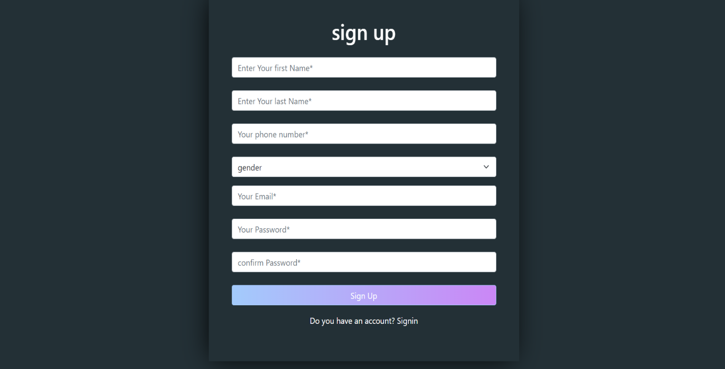

Elements on a Sign-Up Page

All element are required except the gender.

**Input Fields:**

**Name:** first and last name.

**Email Address:** Used for account identification and communication As for emails, it must contain the ‘@’ symbol.

**Password:** For secure account access (with requirements for complexity).

**Gender :** to identification the gender of user

**Phone Number:** Sometimes used for two-factor authentication or additional contact method.

a-Security Features:

Password Confirmation: To ensure the user correctly types the password.

Captcha: To prevent automated sign-ups by bots.

Security Questions: Additional layer of security for account recovery (optional).

b-Verification:

Email Verification: A link or code sent to the user's email to confirm the address is valid.

Phone Verification: A code sent via SMS for verifying the phone number.

sign in page

is a web page where users enter their credentials to access an existing account on a service, application, or website

-User will fill email and password to sign in to the website.

**Email Address:** Used for account identification and communication as for emails, it must contain the ‘@’ symbol.

**Password:** For secure account access (with requirements for complexity).

**If user forget his password will tab into “forget password” then he can make a new password when** **user enter his email**

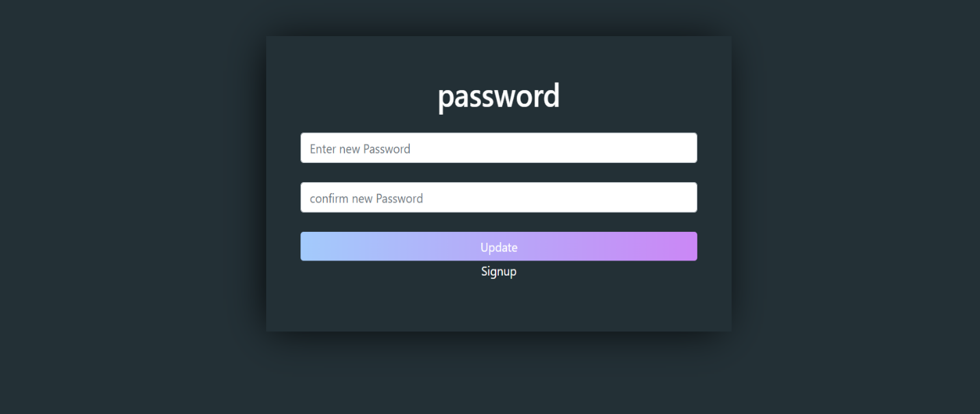**Then he will receives the code and can to register.**

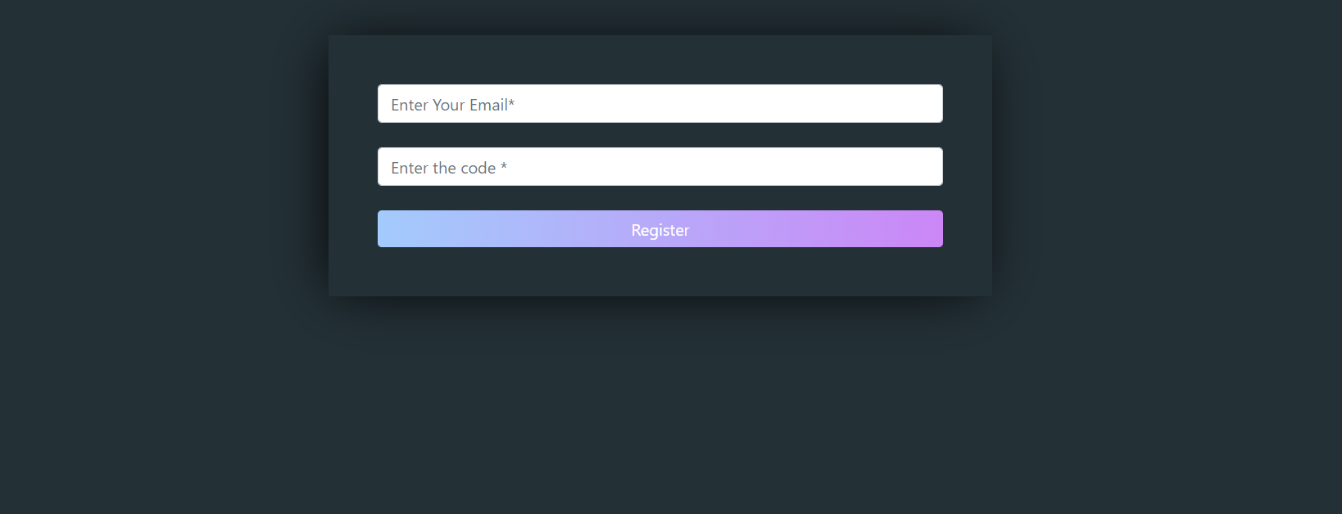4-After that User can make a new password if he forget it and then he must confirm that password .

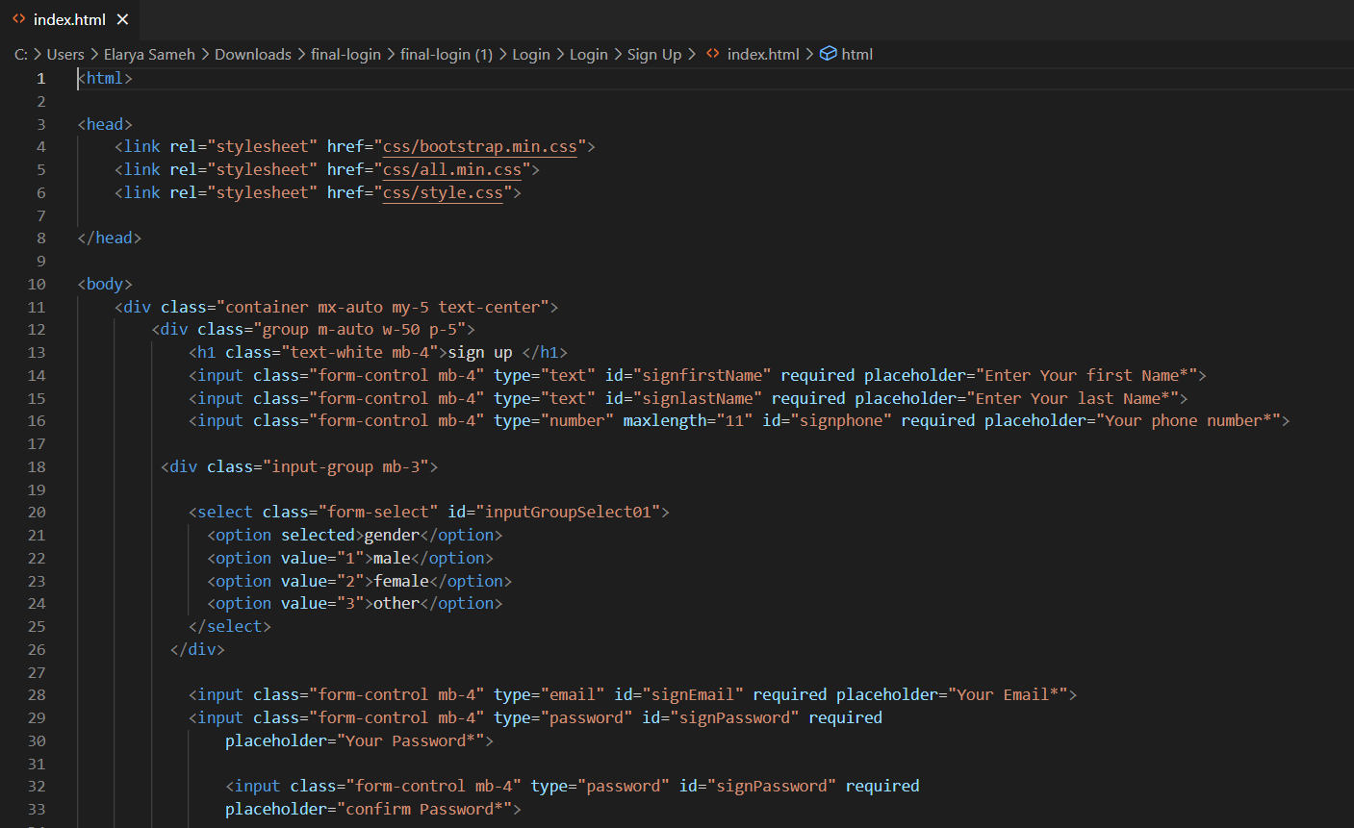**Code :**

Register page: **user enter his email Then he will receives the code and can to register.**

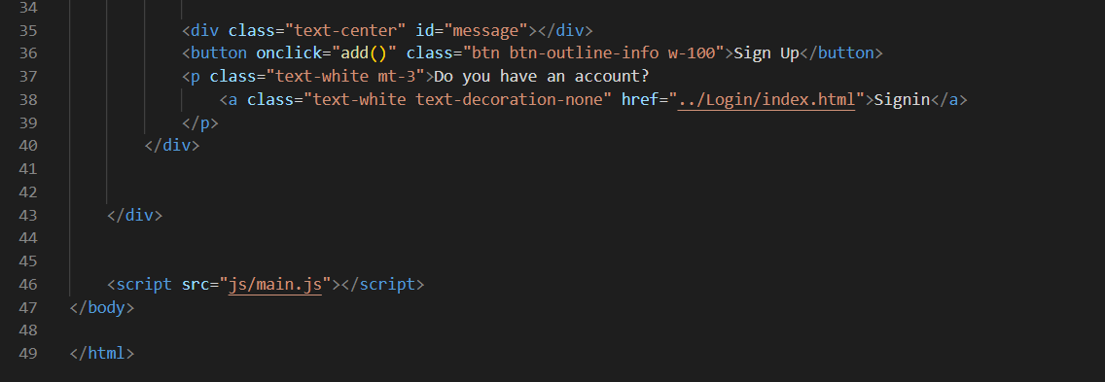

New password : Password and confirm password must be the same

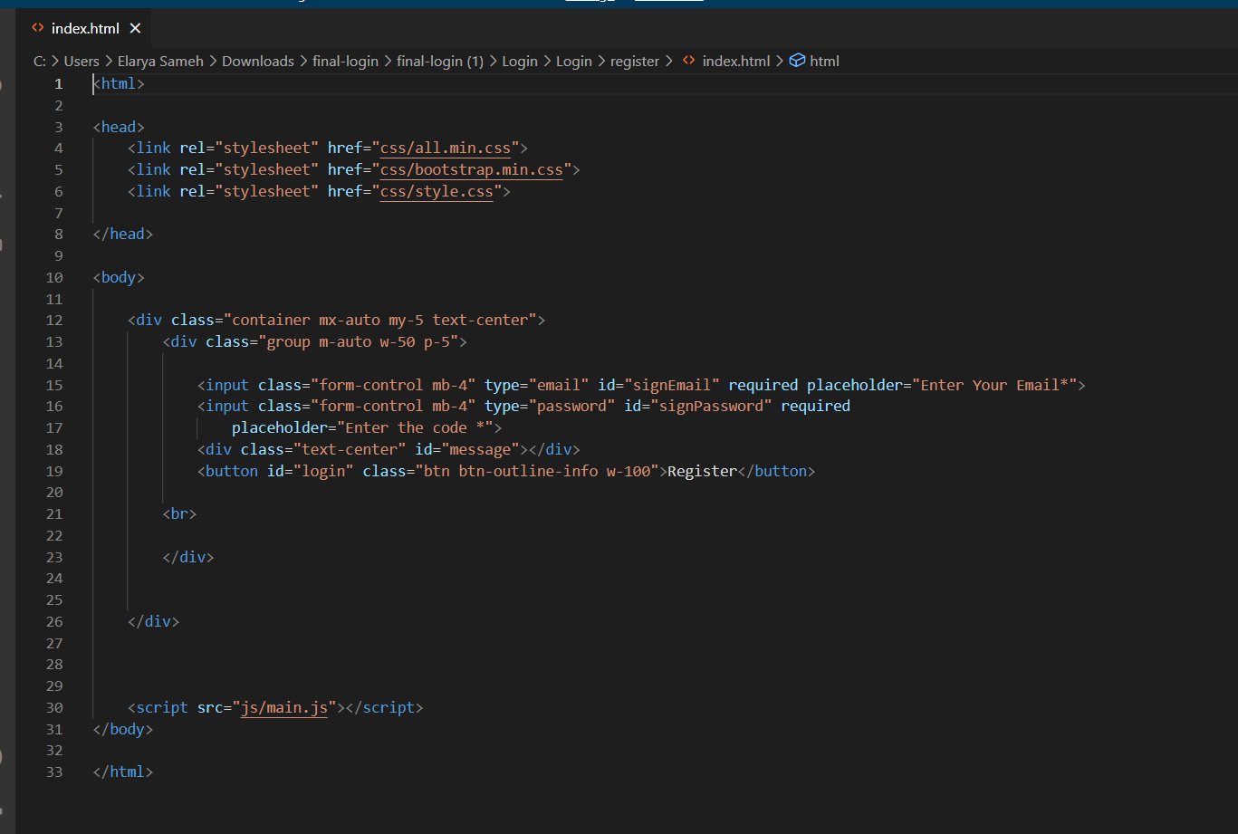

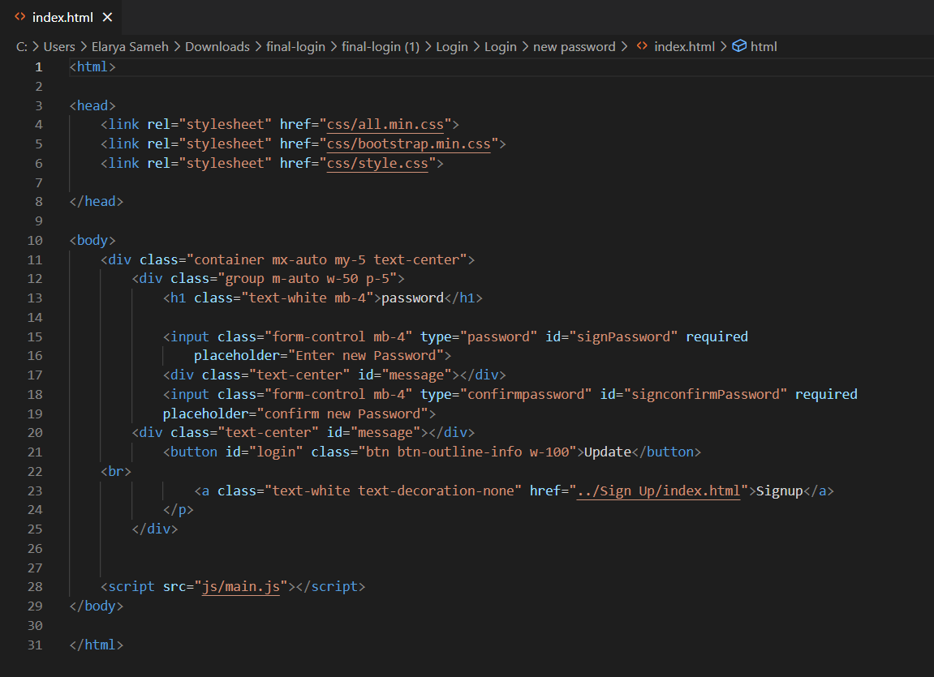

### 2.1.4. Home page

-We use dark and light mood .

-Home page Description of the project content, through which we access the rest of the pages,

-enables the user to learn about the project and facilitates its use.

**Dark mode:**

 **Light mode:**

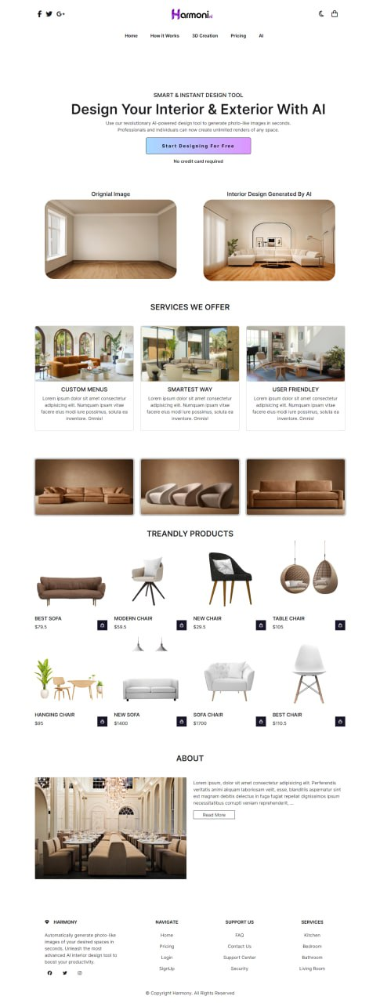

**light and dark code:**

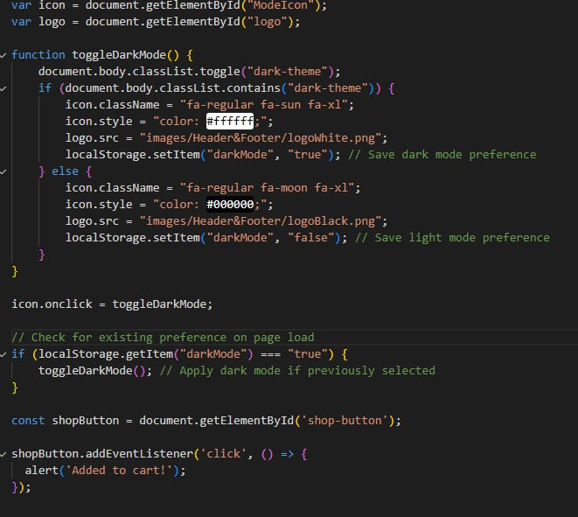

Section 1:

Logo





Navbar :

It contains social media sites and a light & dark button ,and through which you can access any page on the site by clicking on the name of the page on it like ( How it works , features , pricing , Ai )

After that introduction about the website.

Section 2 :

This picture shows before and after the design, adding the furniture, and arranging it in a way that suits the user’s taste

By using Ai .

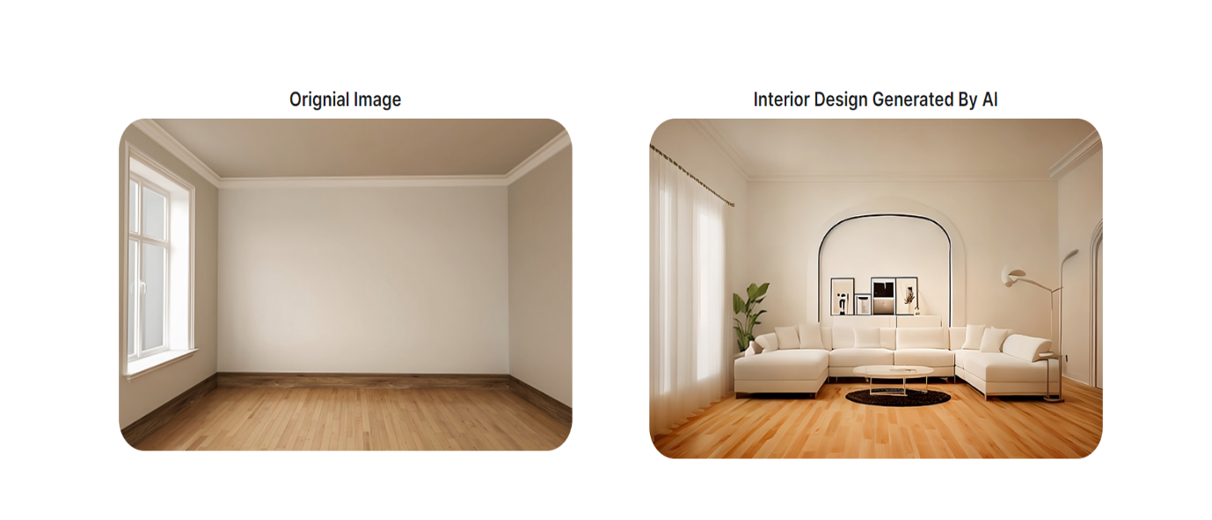

Section 3:

This section shows our services that user need it to help him for Inspiration for the room.

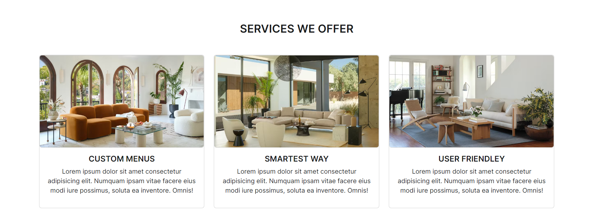

Section 4:

We make it easy for the user to choose through this section because we place the most searched for products in it that suit the user’s taste and are compatible with trendly products.

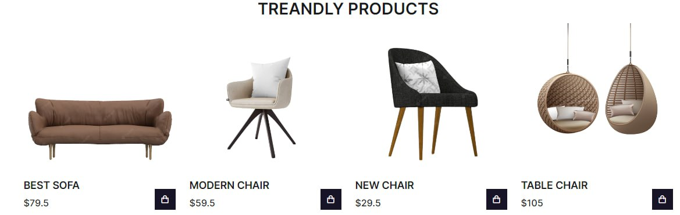

Section 5 :

This is a brief overview of our site that contains all the information that explains to the user

the importance of the project idea and makes it easier for him to use it .

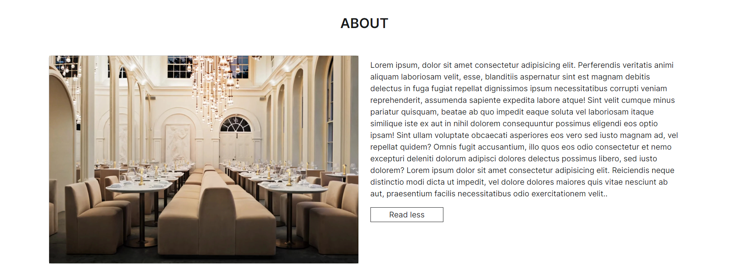

Section 6 :

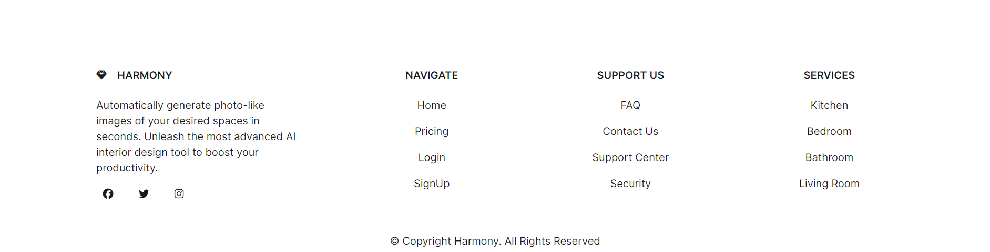Footer : contains social media and user can move from page to page .

Section 7:

-cart

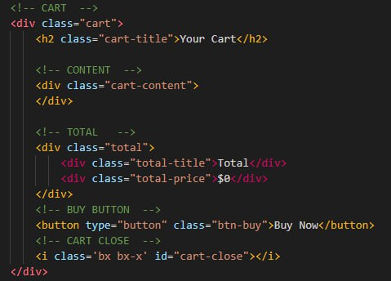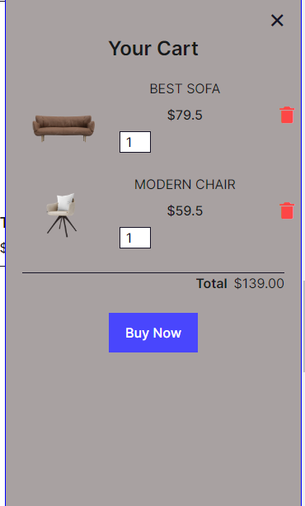

5.2.3. How To Work Page:

Our 'How to Work' page is your comprehensive guide to navigating our platform efficiently and effectively. Whether you're a newcomer seeking a step-by-step introduction or a seasoned user looking for advanced tips and tricks, this page is designed to cater to your needs. Here, you'll find detailed instructions, tutorials, and FAQs covering various aspects of our platform, including account setup, usage guidelines, troubleshooting common issues, and maximizing productivity. With clear explanations and helpful visuals, we aim to empower you to make the most out of your experience with us. Explore our 'How to Work' page and unlock the full potential of our form today.

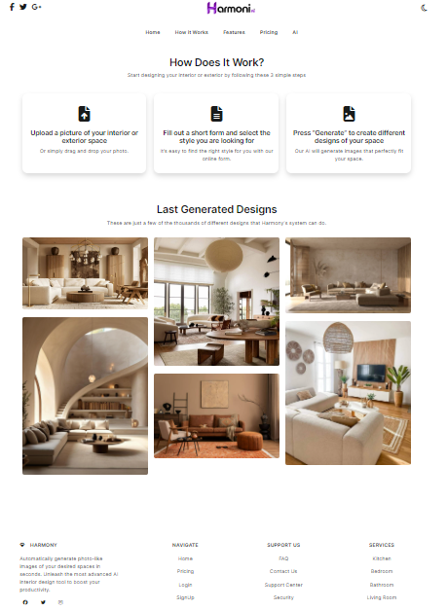

Section 1:

How Does It Work?

Start designing your interior or exterior by following these 3 simple steps.

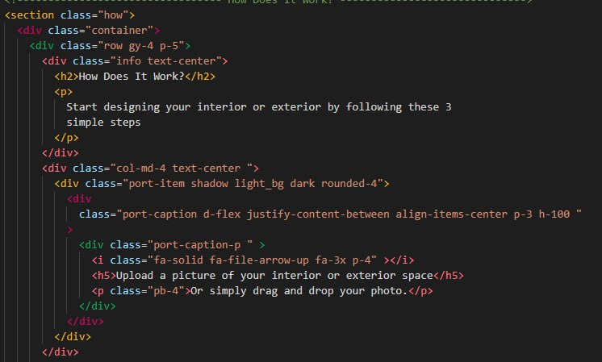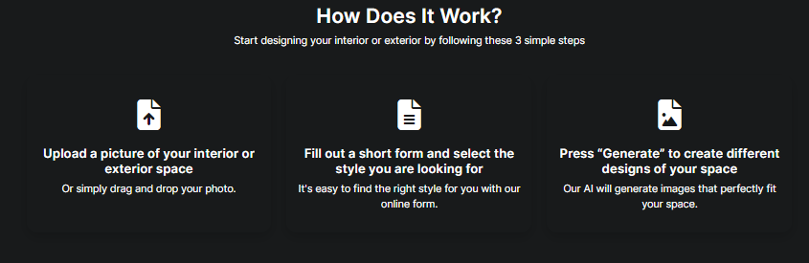

Section 2:

Last Generated Designs:

These are just a few of the thousands of different designs that Harmony's system can do.

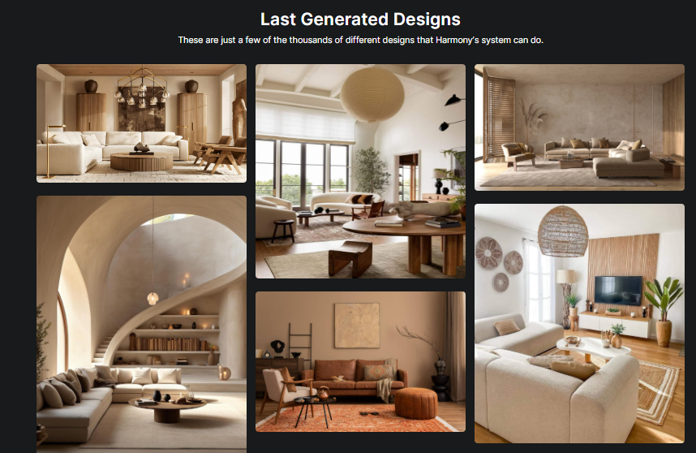

5.2.4.pricing page:

The pricing page is where users can find information about the cost of products or services offered by a business. It typically lists different pricing tiers, packages, or options available to customers, along with their respective features and prices. This page plays a crucial role in helping potential customers understand the value they will receive for their investment and making informed purchasing decisions.

**Dark mode:**

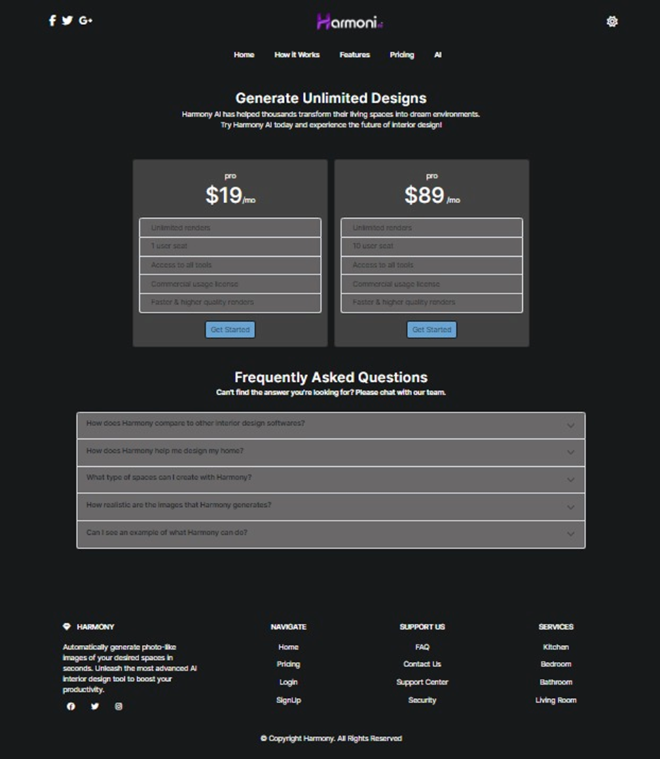

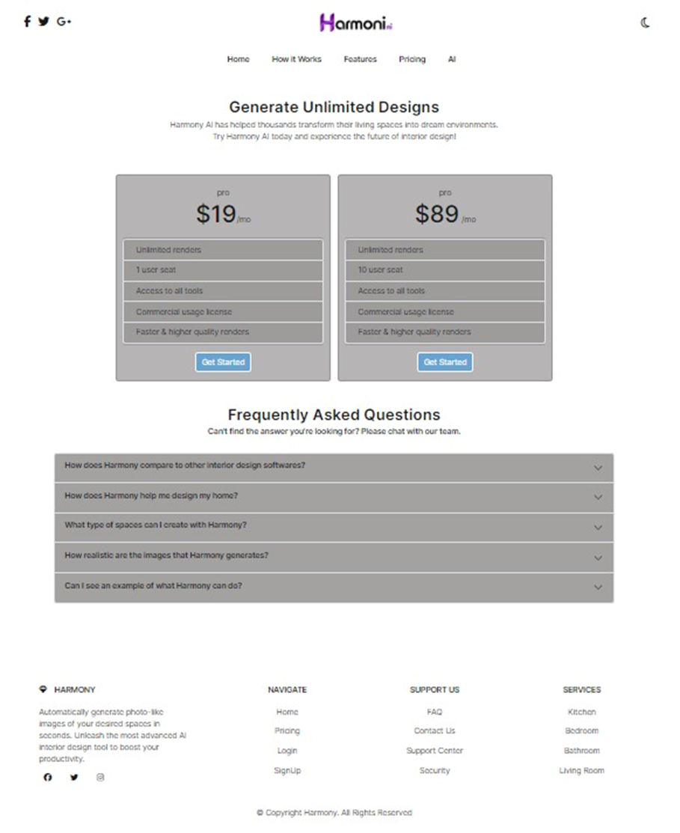**Light mode**:

Section 1:

Generate Unlimited Designs:

harmony Al has helped thousands transform their living spaces into dream environments. Try Harmony Al today and experience the future of interior design.

We have two parts so that we keep up with all categories.

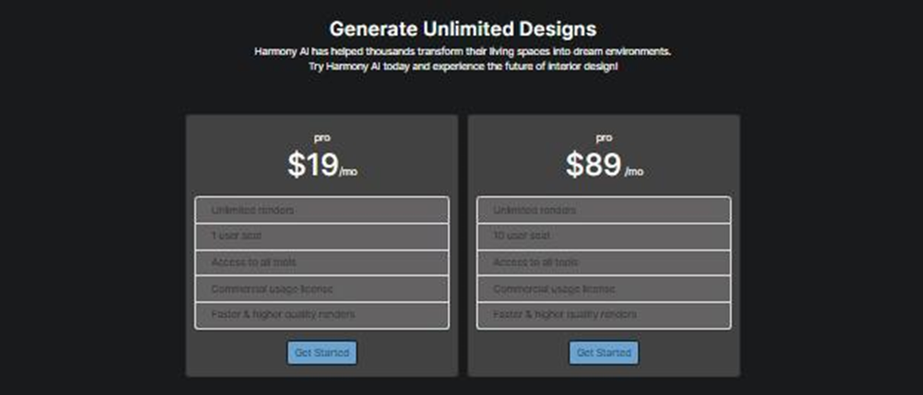

Section 2:

Frequently Asked Questions:

can't find the answer you're looking for? Please chat with our team.

A set of questioning with the answer helps the user to easily understand.

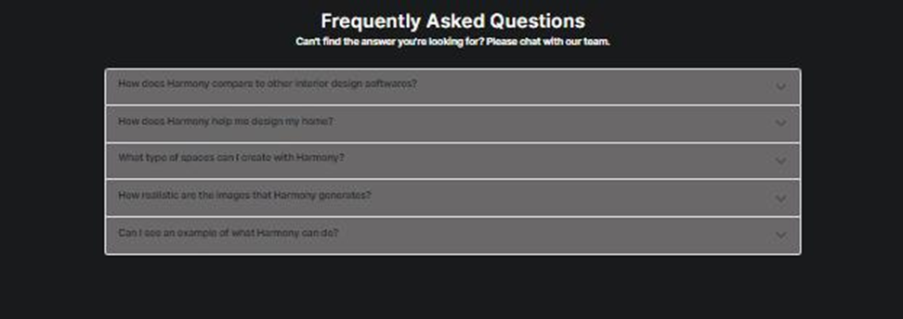

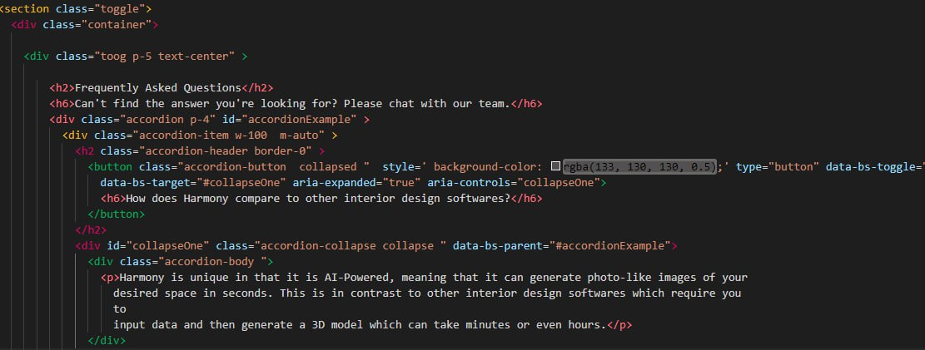

### 2.1.5.CSS Code

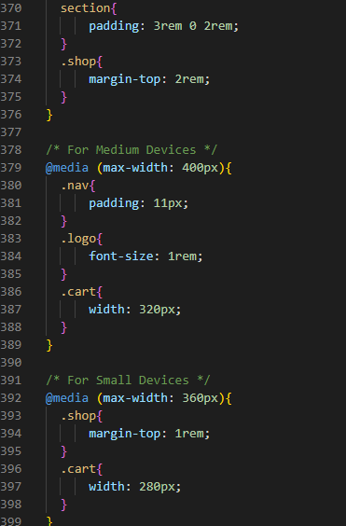

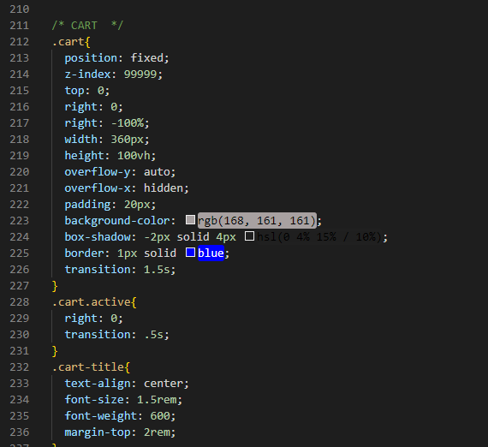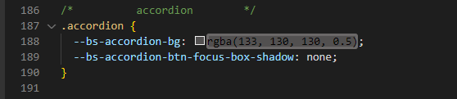

### 2.1.6. JavaScript Code

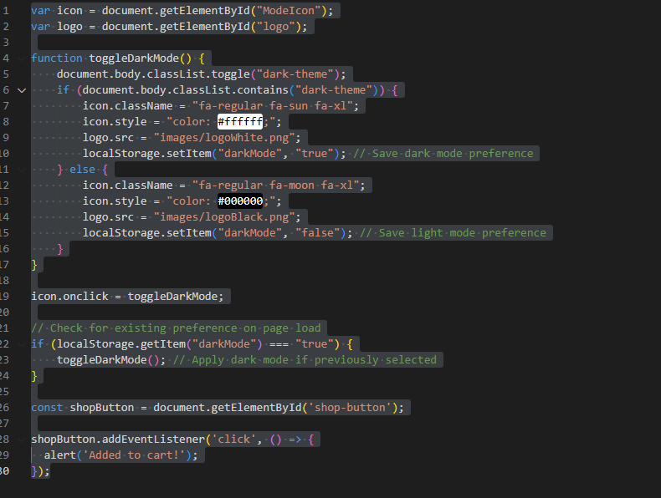

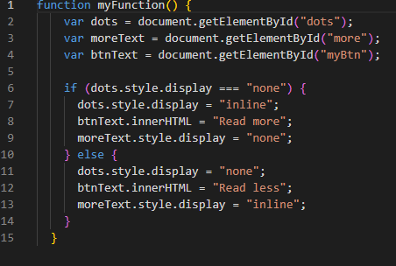

# Chapter 3

# Machine Learning

## 3.1. Introduction and Installation Process

### 3.1.1. Introduction

This documentation provides an overview of the installation process and dependency setup for the provided code. It includes instructions for installing necessary packages and setting up the environment.

## 3.2. Installation Process

The installation process involves installing required Python packages, downloading additional dependencies, and setting environment variables.

### 3.2.1. Installing Dependencies:

The code utilizes various Python packages for functionality. These packages are installed using pip commands. Additionally, some packages are installed from URLs or Git repositories.

### 3.2.2.Downloading Additional Dependencies:

Certain dependencies are downloaded from external sources using wget and git clone commands. These dependencies are essential for the proper functioning of the code.

### 3.3.3. Setting Environment Variables:

Environment variables are set to configure the runtime environment. This includes setting LD_PRELOAD and TF_CPP_MIN_LOG_LEVEL variables.­­

## 3.2. Package Installation and Setup

### 3.2.1. Package Installation

The installation process involves installing Python packages and additional dependencies required for the code to run successfully. The following packages are installed:

**1. wget:**

Used for downloading files from the internet.

**2. pyngrok :**

Utilized for tunneling network connections.

**3.huggingface_hub:**

Library for interfacing with the Hugging Face model hub.

**4.python-slugify:**

Used for generating slugs from strings.

**5.cchardet:**

Charset detection library.

### 3.2.2. Environment Setup

The environment setup includes setting environment variables to configure the runtime environment. The following environment variables are set:

**1.LD_PRELOAD:**

Preloads the specified shared library before any other shared libraries.

**2.TF_CPP_MIN_LOG_LEVEL:**

Sets the TensorFlow log level to suppress unnecessary logging.

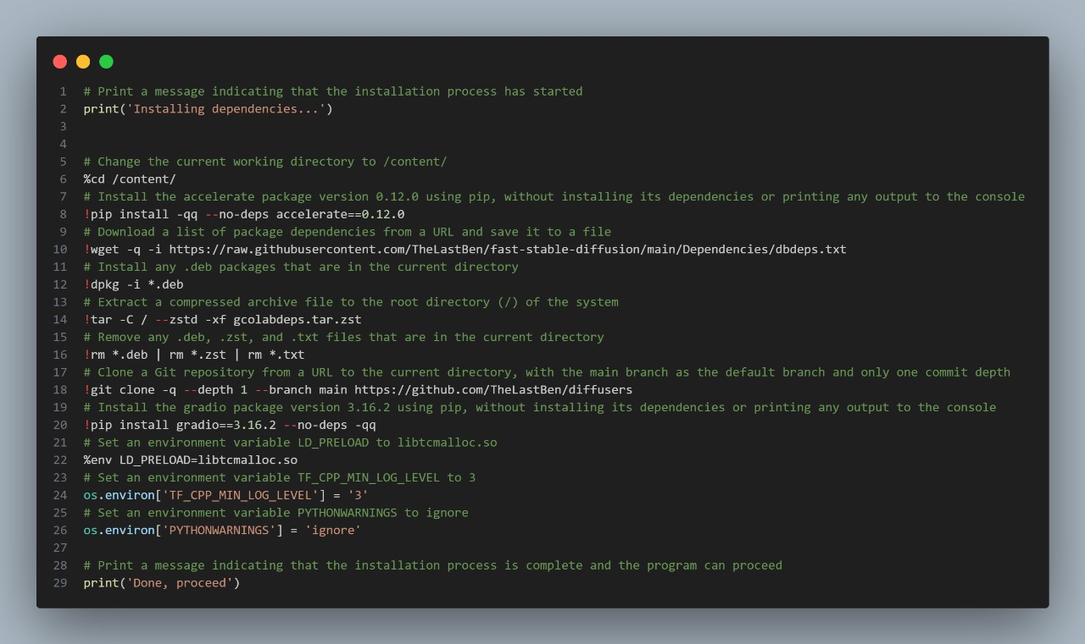

## 3.3. Code Imports and Initializations

### 3.3.1. Code Imports

The code imports the necessary libraries and modules required for execution. These include:

**1.IPython.utils:**

Used for capturing output.

**2. time**:

Standard Python library for time-related functions.

**3. os:**

Operating system interfaces.

**4. wget:**

Library for downloading files.

**5. subprocess:**

Module for executing system commands.

**6. urllib.request:**

Library for making HTTP requests.

**7.base64:**

Module for encoding and decoding binary data as ASCII strings.

**8. google.colab:**

Library for working with Google Colab environment.

**9.PIL:**

Python Imaging Library for image manipulation.

**10.tqdm:**

Library for displaying progress bars.

**11.random:**

Standard Python library for generating random numbers.

**12.slugify:**

Library for converting strings into slugs.

**13.HfApi, CommitOperationAdd:**

Classes for interfacing with the Hugging Face model hub.

### 3.3.2. Initialization

The code initializes certain variables and settings required for subsequent operations. These include:

**1.Setting Working Directory:**

Changes the current working directory to /content/.

**2.Setting Environment Variables:**

Sets environment variables such as LD_PRELOAD and TF_CPP_MIN_LOG_LEVEL.

**3.Setting Environment Variables:**

Sets environment variables such as LD_PRELOAD and PYTHONWARNINGS.

**4.Display Markdown:**

Function for displaying markdown content in the notebook.

## 3.4. Dependency Installation

### 3.4.1. Package Installation (Continued)

The installation process continues with the installation of additional packages and dependencies. These include:

**1.accelerate:**

A package for high-performance computing.

**2.Gradio:**

Library for creating interactive web interfaces for machine learning models.

### 3.4.2. Downloading Dependencies

The code downloads additional dependencies from external sources using “wget” and “git clone” commands. These dependencies are essential for the proper functioning of the code.

## 3.5. Cleanup and Finalization

### 3.5.1. Cleanup

After installing dependencies and setting up the environment, the code performs cleanup tasks to remove unnecessary files and directories. These tasks include:

**1.Removing Files:**

Deletes any .deb, .zst, and .txt files present in the current directory.

**2.Cloning Git Repository:**

Clones a Git repository from a specified URL to the current directory with the main branch and only one commit depth.

## 3.6. Completion Message

### 3.6.1. Completion Message

Upon successful completion of the installation process, the code prints a message indicating that the installation process is complete and the program can proceed.

## 3.7. Model Download and Setup

### 3.7.1. Model Download

The code downloads the model from the Hugging Face model hub based on the specified version (Model_Version). If a custom model path (MODEL_PATH) or link (MODEL_LINK) is provided, the code uses it for downloading the model.

**1. Model Version and Path:**

The model version (Model_Version) and path to the Hugging Face model (Path_to_HuggingFace) are specified.

**2. Downloading Model:**

The code utilizes functions such as ‘downloadmodel()’, ‘newdownloadmodel()’, ‘newdownloadmodelb()’, or custom model download logic based on provided parameters to download the model.

### 3.7.2. Model Setup

After downloading the model, the code performs additional setup tasks to prepare the model for use.

**1.Model Path and Name:**

The path to the downloaded model (MODEL_NAME) is determined based on the version and availability.

**2.Model Detection and Conversion:**

If necessary, the code detects the model version and converts it to the appropriate format using conversion scripts (convertodiff.py) or custom logic.

**3.Verification:**

The code verifies the downloaded model and checks for any errors or inconsistencies.

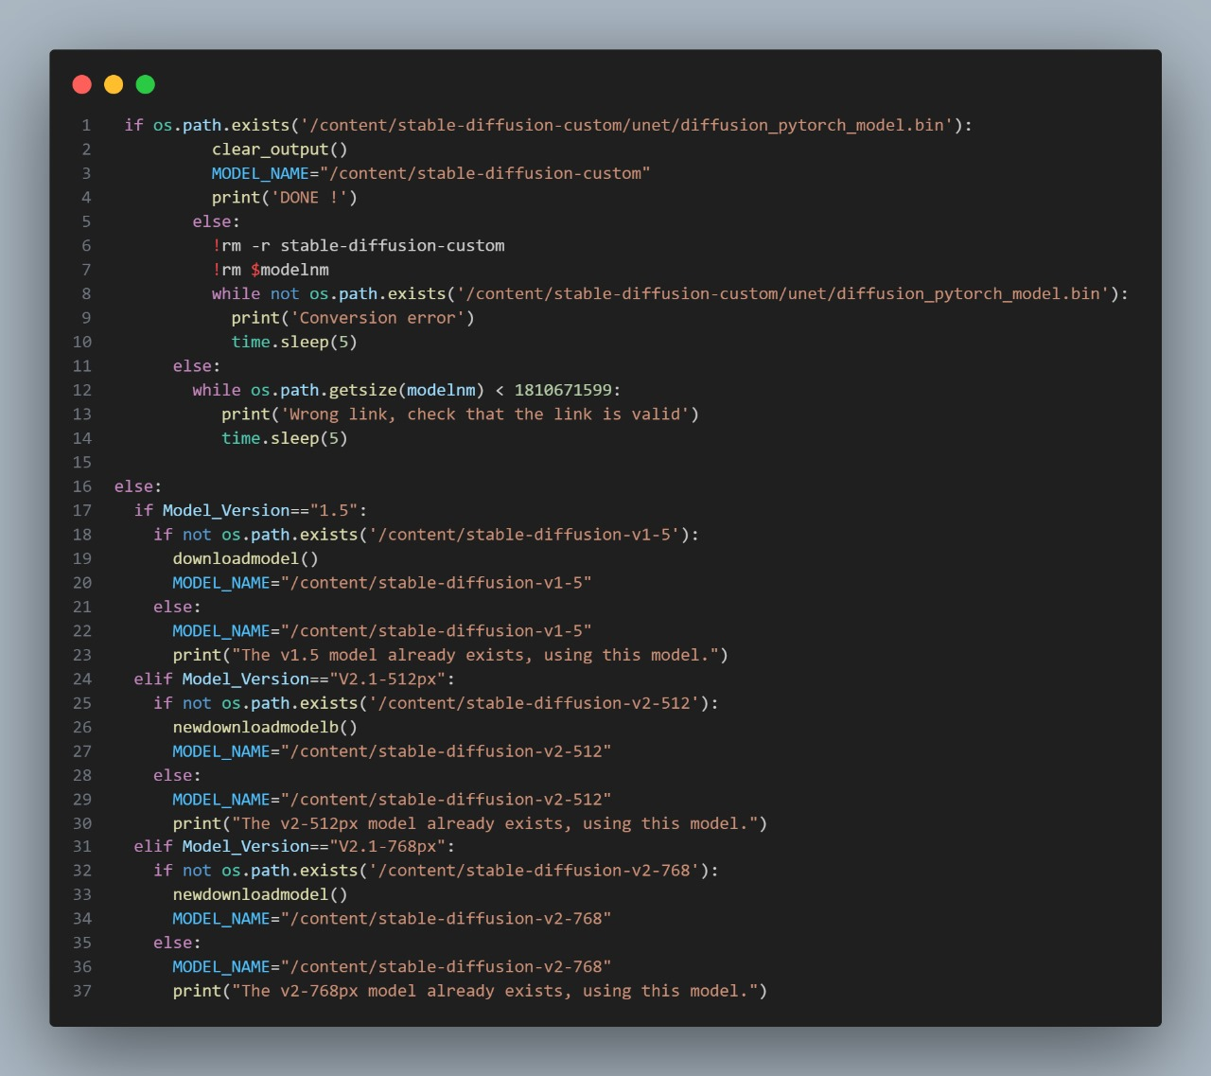

## 3.8. Finalization and Verification

### 3.8.1. Finalization

Once the model is downloaded and set up, the code finalizes the process and provides confirmation of completion.

**1. Confirmation Message:**

A message indicating the successful completion of the model download and setup process is displayed.

**2. Error Handling:**

The code includes error-handling mechanisms to address any issues that may arise during the download or setup process.

## 3.9. Variable Declaration and Session Initialization

### 3.9.1. Variable Declaration

The code declares and initializes several important variables used throughout the session. These include:

**1.PT:**

Placeholder variable for PyTorch.

**2.Session_Name:**

Name of the session, used for organizing workspace and output.

**3.Session_Link_optional:**

Optional link for downloading session files.

**4.WORKSPACE:**

Directory path for the workspace where session files are stored.

**5.MODEL_NAME:**

Name of the model if provided.

### 3.9.2. Session Initialization

The code initializes the session by checking for the existence of the session name and downloading session files if a link is provided.

## 3.10. Instance and Concept Images Setup

### 3.10.1. Instance and Concept Images

The code sets up directories for instance and concept images used in the session.

**1.Directories:**

Directories are created for instance and concept images based on the session name.

**2.Paths:**

Paths to instance and concept image directories are defined.

## 3.11. Model Loading and Setup

### 3.11.1. Model Loading

The code handles the loading and setup of the model for the session.

**1.Loading Model:**

If a model path exists, the code loads the model and checks its version.

**2.Model Version Detection:**

The code detects the version of the loaded model.

**3.Model Conversion:**

If necessary, the code converts the model to the appropriate format using conversion scripts.

## 3.12. Instance Image Upload and Preprocessing

### 3.12.1. Instance Image Upload

The code facilitates the upload and preprocessing of instance images for the session.

**1.Variables Initialization:**

Several variables are initialized to configure the instance image upload and preprocessing process. These include flags for removing existing instance images, specifying the folder for images, and enabling smart cropping.

**2.Image Preprocessing:**

The code handles the preprocessing of instance images, including smart cropping if enabled.

**3.Renaming Files:**

File renaming operations are performed to ensure compatibility and consistency.

**4.Archive Creation:**

The final step involves archiving the uploaded instance images and captions for storage and organization.

## 3.13.Training the model

### 3.13.1Overview

This script is designed to train a UNet model and a Text Encoder for a machine learning project. It supports resuming training, adjusting training steps and learning rates, saving checkpoints, and configuring various training parameters.

### 3.13.2. Setup Instructions

**1.Prepare the environment:**

Ensure all necessary libraries are installed and the required data directories (INSTANCE_DIR, CONCEPT_DIR, CAPTIONS_DIR, OUTPUT_DIR, SESSION_DIR) are set up.

**2.Configure parameters:**

Adjust the parameters in the script to match your training requirements.

### 3.13.3. Parameters

**Resume_Training:** (bool) Set to True to resume training from a checkpoint.

**UNet_Training_Steps:** (int) Number of training steps for the UNet.

**UNet_Learning_Rate:** (float) Learning rate for the UNet.

**Text_Encoder_Training_Steps:** (int) Number of training steps for the Text Encoder.

**Text_Encoder_Learning_Rate:** (float) Learning rate for the Text Encoder.

**Text_Encoder_Concept_Training_Steps:** (float) Learning rate for concept training of the Text Encoder.

**Offset_Noise:** (bool) Set to True to use offset noise during training.

**Save_Checkpoint_Every_n_Steps:** (bool) Set to True to save checkpoints every n steps.

**Save_Checkpoint_Every:** (int) Number of steps between checkpoints.

**Resolution:** (str) Resolution of the model.

**Start_saving_from_the_step:** (int) Step number from which to start saving checkpoints.

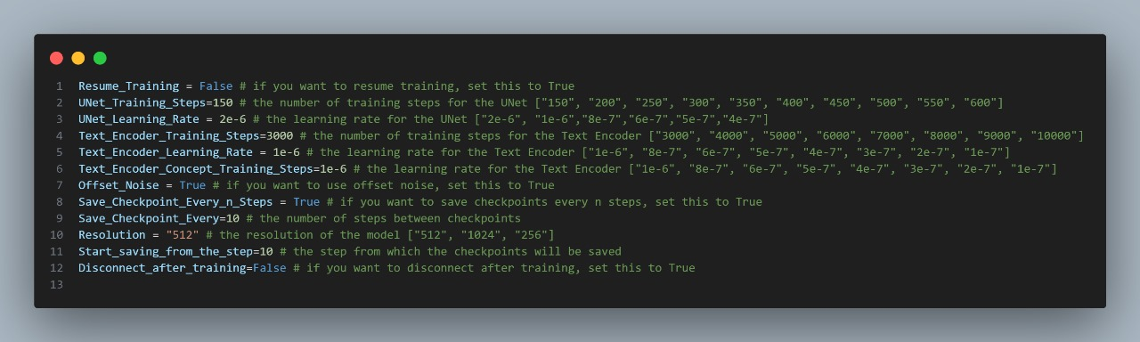**Disconnect_after_training:** (bool) Set to True to disconnect after training.

## 3.14. Key Functions

‘dump_only_textenc(trnonltxt, MODELT_NAME, INSTANCE_DIR, OUTPUT_DIR, PT, Seed, precision, Training_Steps)’

This function handles training only the text encoder.

## 3.14.1. Parameters F1:

* trnonltxt: Command-line argument for training only the text encoder.
* MODELT_NAME: Name of the model to train.
* INSTANCE_DIR: Directory containing instance data.
* OUTPUT_DIR: Directory to save output data.
* PT: Instance prompt.
* Seed: Seed for random number generation.
* precision: Precision type (fp16 or no).
* Training_Steps: Number of training steps.

‘train_only_unet(stpsv, stp, SESSION_DIR, MODELT_NAME, INSTANCE_DIR, OUTPUT_DIR, PT, Seed, Res, precision, Training_Steps)’

This function handles training only the UNet model.

## 3.14.2. Parameters F2:

* stpsv: Save starting step.
* stp: Save every n steps.
* SESSION_DIR: Directory for the training session.
* MODELT_NAME: Name of the model to train.
* INSTANCE_DIR: Directory containing instance data.
* OUTPUT_DIR: Directory to save output data.
* PT: Instance prompt.
* Seed: Seed for random number generation.
* Res: Resolution of the model.
* precision: Precision type (fp16 or no).
* Training_Steps: Number of training steps.
* Seed: Seed for random number generation.
* Res: Resolution of the model.
* precision: Precision type (fp16 or no).

Training_Steps: Number of training steps.

### 3.15. Model Output

### 3.15.1. Bathroom

**Before** 

**After**

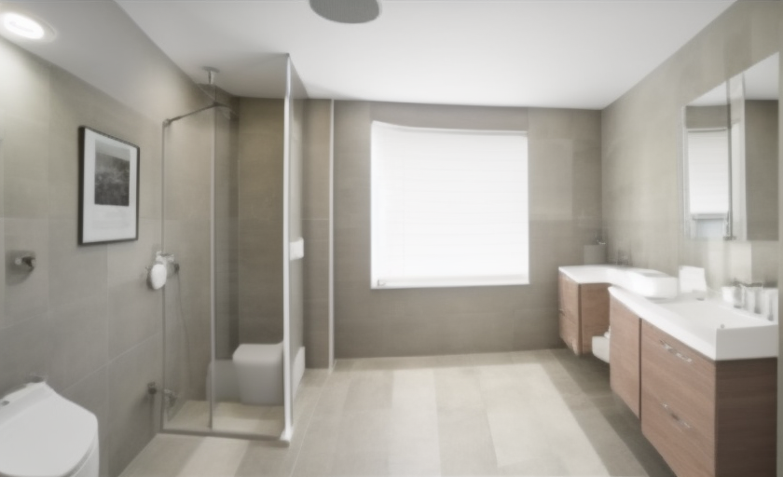

### 3.15.2. Bedroom

**Before**



**After**

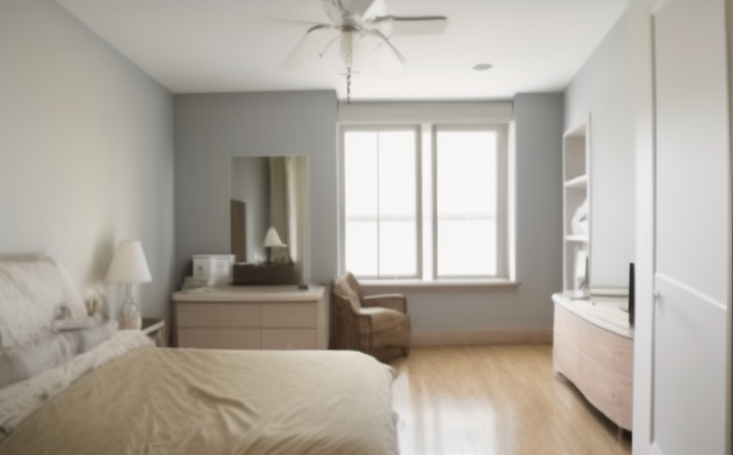

### 3.15.3. Dining Room

**Before**



**After**

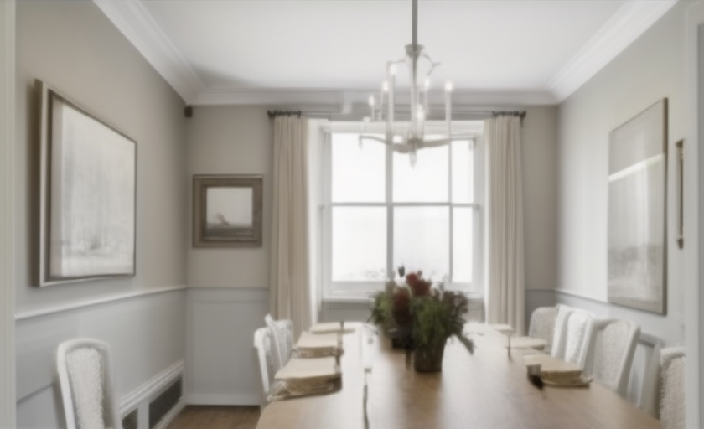

### 3.15.4. Kitchen

**Before**



**After**

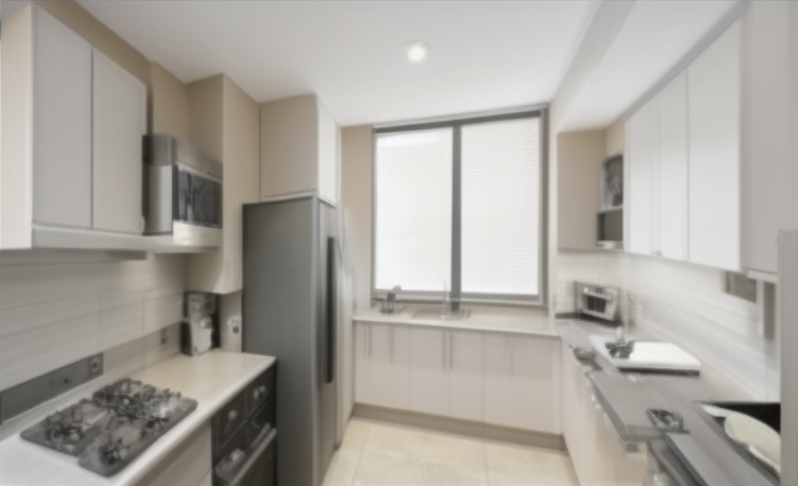

### 3.15.5. Lining Room

**Before**



**After**

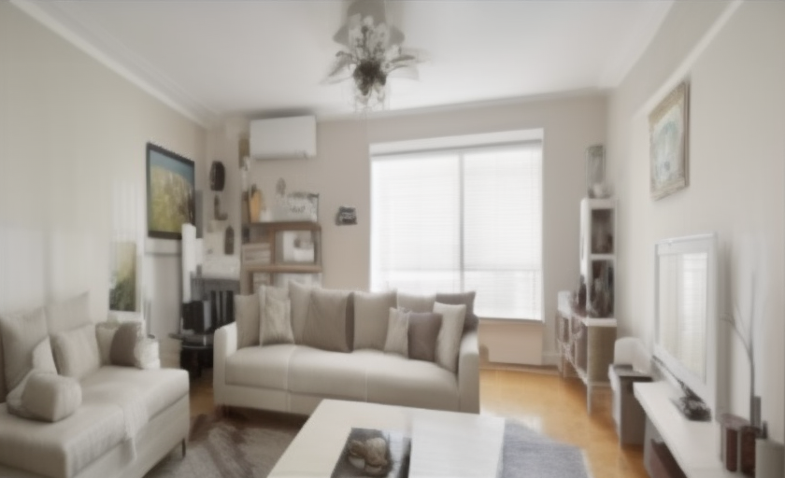

# 3.16.**Ai Page Contant**

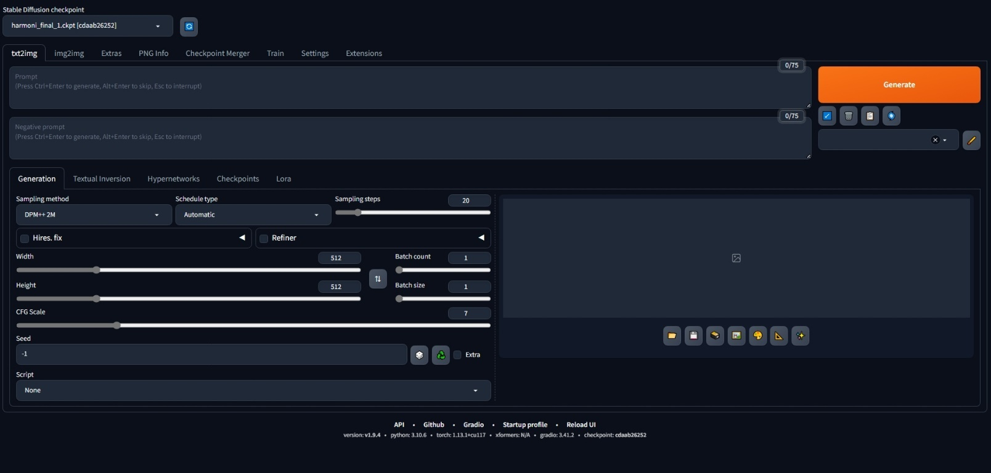

### 3.16.1.Top Section

**1.Stable Diffusion Checkpoint:**

This dropdown allows you to select the model checkpoint you want to use for image generation. The selected checkpoint is harmoni_final_1.ckpt.

### 3.16.2.Main Tabs

**1.txt2img:**

This tab is for generating images from textual descriptions (prompts).

**2.img2img:**

This tab is used for generating images from other images by modifying the input image based on a textual description.

**3.Extras:**

Provides additional functionalities and settings for advanced usage.

**4.PNG Info:**

Displays metadata and other information about generated images.

**5.Checkpoint Merger:**

Allows you to merge different model checkpoints to create a new model with combined features.

**6.Train:**

Provides options for training and fine-tuning models on new data.

**7.Settings:**

General settings for configuring the interface and underlying model.

**8.Extensions:**

Options to add or manage extensions that enhance the functionality of the interface.

### 3.16.3.Prompt Area

**1.Prompt:**

The text box where you enter the description of the image you want to generate. You can press Ctrl+Enter to generate an image, Alt+Enter to skip, or Esc to interrupt.

1. **Negative Prompt:**

Text box for specifying aspects you want to avoid in the generated image.

### 3.16.4.Generation Settings

**1.Sampling Method:**

Dropdown to select the sampling method. Here, DPM++ 2M is selected, which is a specific algorithm used during the image generation process.

**2.Schedule Type:**

Controls the schedule of the sampling process. It’s set to Automatic.

**3.Sampling Steps:**

Slider to adjust the number of steps the model takes to generate an image. More steps can lead to higher quality but take more time. Set to 20 in this case.

**4.Hires. fix:**

Checkbox and associated settings for enabling high-resolution image generation.

**5.Width and Height:**

Sliders to adjust the dimensions of the generated image. Both are set to 512 pixels in this screenshot.

**6.CFG Scale (Classifier-Free Guidance Scale):**

Slider to adjust the guidance scale, which controls how much the image generation process follows the prompt. Higher values can make the image adhere more closely to the prompt. Set to 7 in this case.

**7.Seed:**

Numeric input to set the random seed for image generation. Using the same seed with the same prompt will produce the same image. Set to -1, which typically means a random seed is used.

**8.Batch Count and Batch Size:**

Batch count is set to 1, which means how many sets of images to generate. Batch size is set to 1, indicating the number of images to generate per set.

### 3.16.5.Additional Controls

**1.Script:**

Dropdown to select scripts for additional functionality or post-processing.

**2.Generate Button:**

The orange button that starts the image generation process based on the provided prompt and settings.

### 3.16.6.Bottom Section

**1.Control Icons:**

Icons for loading, saving, copying, and other operations related to generated images.

**2.Status and Info Bar:**

Displays the status of the UI and model, such as API version, Python version, Torch version, Gradio version, and checkpoint information.

# Chapter 4

# Create Room “3D”

## 4.1. Vite & Three.js in Our Project

### 4.1.1. Why using Vite

In our project, we leverage Vite as our front-end build tool to streamline the development of our Three.js application.

**Vite** is a modern, fast build tool that significantly enhances the developer experience by providing features like **instant server start**, lightning-fast Hot Module Replacement (HMR), and efficient bundling for production. It utilizes native ES modules in the browser, allowing for rapid development without the need for complex configurations.

The choice of Vite for this project is driven by its simplicity, speed, and the seamless integration it offers with Three.js and other modern web technologies. By simplifying the setup process and offering an optimized development environment, Vite enables us to focus on developing immersive 3D web experiences with Three.js, without being bogged down by build tool configurations.

### 4.1.2. Why Choose Three.js for Our Project

Before diving into the rationale behind selecting Three.js, it's essential to understand the landscape of web-based 3D technologies:

* **WebGL:** WebGL is a low-level JavaScript API for rendering interactive 3D and 2D graphics within any compatible web browser, without the use of plug-ins. While powerful, WebGL is complex and requires detailed knowledge of rendering pipelines and shader programming.
* **Three.js:** Built on top of WebGL, Three.js is a high-level library that simplifies the creation of 3D graphics. It provides a wide array of features, such as cameras, materials, lights, and more, abstracting away the complexities of WebGL.
* **Spline:** Spline is a web-based tool that allows designers and developers to create 3D content visually, without deep knowledge of the underlying 3D modeling concepts or code.

Given the options, we chose Three.js for our project for several reasons:

* **Abstraction Over WebGL:** Three.js provides a much-needed layer of abstraction over WebGL, making it more accessible for developers to create complex 3D visualizations without delving into the intricacies of WebGL's low-level API.
* **Community and Ecosystem:** Three.js has a large and active community, offering a wealth of examples, plugins, and extensions that accelerate development.
* **Balance Between Power and Simplicity:** While tools like Spline are excellent for designers or quick prototyping, Three.js offers a balance, providing both the power to create complex 3D scenes programmatically and the simplicity to get started quickly.

**Conclusion**

By combining Vite with Three.js, our project benefits from a modern development workflow that is both fast and efficient, allowing us to focus on creating engaging 3D web experiences. The choice of Three.js, with its balance of power and ease of use, empowers our team to build complex 3D visuals and applications that are accessible, performant, and visually striking.

## 4.2. Imports

In my project, the use of import statements plays a critical role in the structure and functionality of the code. They are essential for modularizing the code, efficiently managing the resources needed, and expanding functionality through **third-party libraries**.

**Firstly,** by modularizing the code through import statements, my project becomes more organized and easier to maintain. It allows for the reuse of functions, classes, data, etc., where needed, reducing redundancy, and maintaining consistency. This contributes to the scalability of the project, enabling new features or updates to be added without extensive rework.

**Secondly,** by importing only what is necessary, resource usage is optimized. Instead of loading entire libraries, only the required parts are imported, which shortens load times and boosts the efficiency of the application. The use of dynamic imports allows for loading modules on-demand, improving initial load times and the overall user experience.

**Thirdly,** import statements make it easy to integrate third-party libraries like Three.js, enabling the implementation of complex functionalities beyond the basic capabilities of JavaScript.

For example, **Three.js** is essential for rendering 3D graphics in a web browser, **OrbitControls** offer an intuitive way for users to explore 3D models from all angles, **Sky** enhances visual quality and realism, and **GLTFLoader** is crucial for loading complex, high-quality external 3D models. **DragControls** and **TransformControls** play a significant role in applications requiring user interaction with the 3D environment by enabling users to manipulate objects within the scene.

The importance of import statements in my project goes beyond just being a technical requirement. They ensure that the code remains maintainable and scalable while providing the necessary functionalities for a compelling user experience.

To ensure clarity and provide a comprehensive understanding, let's break down key import statements that might be used in a typical 3D project using Three.js, detailing the purpose and significance of each.

|  |
| --- |
| *// Import necessary modules from three.js*  import * as THREE from 'three';  import { OrbitControls } from 'three/examples/jsm/controls/OrbitControls.js';  import { Sky } from 'three/addons/objects/Sky.js';  import { GLTFLoader } from 'three/addons/loaders/GLTFLoader.js';  import { items } from './items.js';  import { DragControls } from 'three/addons/controls/DragControls.js';  import { TransformControls } from 'three/addons/controls/TransformControls.js'; |

### 4.2.1.Three.js Core

This import statement brings in the entire **Three.js library** [1], providing access to essential functionalities like creating **scenes**, **cameras**, **lights**, **materials**, and more. It's the foundation for any project that involves rendering 3D graphics in a web browser.

### 4.2.2. OrbitControls

**OrbitControls** [2] allow users to interact with the 3D scene using **mouse** or **touch inputs**. It enables the camera to orbit around a target, zoom in and out, and pan across the scene, making it an essential tool for enhancing the user experience by allowing intuitive navigation and exploration of the 3D environment.

### 4.2.3. Sky Shader

The **Sky** [3] import adds a dynamic skybox to the scene, simulating various atmospheric conditions. It can be used to create realistic lighting and atmospheric effects based on the sun's position, enhancing the visual appeal and realism of the 3D environment.

### 4.2.4. GLTFLoader

The **GLTFLoader** [4] is used for loading 3D models in the **GLTF** format, which is a standard file format for three-dimensional scenes and models. GLTF is popular for its efficient compression and capability to store complex animations, making it ideal for web projects. This loader enables the inclusion of high-quality 3D models into your scene.

### 4.2.5. DragControls

**DragControls** [5] allow objects in the scene to be picked up, moved, and placed using mouse or touch inputs. It's particularly useful in applications requiring interactive elements, such as games or design tools, providing a straightforward way for users to manipulate objects in the 3D space.

### 4.2.6. TransformControls

**TransformControls** [6] This import provides a visual interface (gizmo) for **translating** (moving), **rotating**, and **scaling** objects within the scene. It enhances the interactivity of the scene, allowing users to edit objects in a more intuitive and precise manner. This is especially useful in applications like 3D modelling tools or any scenario where object manipulation is required.

### 4.2.7. Items Module

The items.js module is a custom component that defines a collection of items to be used within the 3D scene.

Each item object contains:

* **name:** A unique identifier for quick reference.
* **image:** A visual representation for UI elements or previews, aiding in the selection process.
* **model:** The path to a **GLB file**, allowing for the integration of detailed 3D models into the scene.

|  |
| --- |
| var items = [    {      "name": "Washerdryerstacked",      "image": "./images/glbPNG/washerDryerStacked.png",      "model": "./images/glb/washerDryerStacked.glb"    }  ]  export { items }; |

Each of these imports plays a specific role in building and enhancing a 3D scene, contributing to the project's interactivity, realism, and usability. By understanding the purpose and application of each, developers can effectively leverage the Three.js library to create immersive and interactive 3D web applications.

## 4.3. Toggle dark mode

Implements a feature that allows users to switch between light and dark themes in a web application.

### 4.3.1. Detailed Explanation

This code enhances user experience by enabling visual theme selection to accommodate different lighting conditions during day and night.

### 4.3.2. Key Components

Global Variable Declarations: Declares theme and color-related variables. The default theme is set to **'light'**.

**updateColors Function**: Updates the values of **lineColor**, **fillColor**, **strokeColor** variables according to the current theme.

**toggleDarkMode Function**: Toggles the theme upon user icon click. This function toggles a class on the DOM element, updates color variables, and redraws canvas content to match the new theme.

### 4.3.3. Flow of Execution

The user clicks the theme **toggle icon**.

Toggles the existence of the "**dark-theme**" class on document.body.

Updates the global theme variable and DOM elements' attributes based on the current theme state.

Calls the **updateColors** function to adjust color variables for the new theme.

Clears the canvas and redraws the grid and lines/shapes to match the new theme.

## 4.4. 2D view

### 4.4.1. Canvas and its drawing context

how to draw a grid on an HTML canvas, which can adjust its color based on the current theme (light or dark mode) chosen by the user.

Here's a breakdown of how it works:

**Obtaining the Canvas and Context:** The canvas and context variables are used to access the HTML canvas element and its 2D drawing context. This enables drawing graphics on the canvas.

**Setting the Grid Size:** The **gridSpacing** variable defines the spacing between grid lines. In this example, the spacing is set to **20 pixels**.

**The drawGrid Function:** This function draws vertical and horizontal lines across the canvas to form a grid.

Vertical lines are drawn across the canvas width, and horizontal lines are drawn across the canvas height.

The **context.strokeStyle** property is used to set the color of the lines. This color is determined by the **updateColors function** to match the theme.

**Updating Colors Based on Theme:** **The updateColors function** is called to set initial colors according to the theme. This function, part of the **toggleDarkMode** functionality, updates color-related variables **(lineColor, fillColor, strokeColor)** whenever the user switches themes.

**Executing Grid Drawing:** Finally, the drawGrid function is called to draw the grid on the canvas.

enabling users to draw interconnected lines and points dynamically with their mouse movements and clicks. It's an interactive way to create and visualize shapes on a 2D canvas.

Here's a detailed explanation of how it functions:

### 4.4.2. Core Components

**Shapes Array:** Initializes with an array containing an empty array to store points for the first shape. Each shape is represented by an array of point objects, where each point object has x and y properties.

**addPoint Function**: Adds a new point with the specified x and y coordinates to the current shape (the last shape in the shapes array).

**redrawLines Function:** Iterates over all shapes and draws lines connecting each point within a shape.

For each shape:

* If a shape has less than two points, it skips drawing lines (since at least two points are needed to draw a line).
* Sets the stroke color for lines.
* Begins a new path from the first point, then iterates over all points in the shape, drawing lines to each.
* Draws a filled circle at each point's location to represent the point visually.

**updateCanvas Function:** Triggered by mouse movement over the canvas. It:

* Clears the canvas.
* Redraws the grid and all shapes with their connecting lines and points.
* Draws a line from the last point of the current shape to the current mouse position, showing where the next point will be placed.
* Draws a point at the current mouse position, giving a preview of where the next point will be added.

**Event Listeners:**

**onmousemove:** Calls updateCanvas, updating the canvas with a preview line and point following the mouse.

**onmousedown and onclick:** Adds a new point where the mouse clicks, using the addPoint function.

**ondblclick:** Starts a new shape by adding a new empty array to the shapes array.

### 4.4.3. Usage

**Drawing Lines and Points:** Click on the canvas to add points. Lines automatically connect these points, forming shapes. Points are visually represented as filled circles.

**Continuing a Shape:** Keep clicking to add more points to the current shape. Each click adds a new point connected by lines to the previous ones.

**Starting a New Shape:** Double-click on the canvas to start a new shape. This doesn't interrupt the drawing of the previous shape; it simply starts collecting points for a new one.

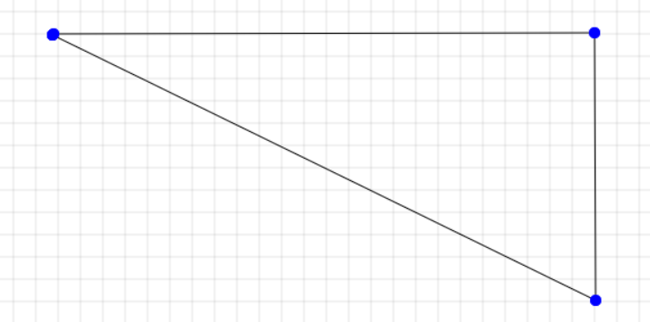

## 4.5. 3D view

create an interactive 3D scene using Three.js, a widely-used JavaScript library for rendering 3D graphics in a web browser via WebGL.

This script meticulously sets up a basic 3D environment, incorporating elements such as a **perspective camera**, **ambient** and **directional lighting**, a **textured floor**, and intuitive **camera** controls for user interaction. It also establishes an animation loop that continuously renders the scene and dynamically adjusts the opacity of shapes based on their intersection with a **raycaster**, thereby enhancing the interactive experience.

Here's a breakdown of its functionality:

### 4.5.1. Detailed Setup Functions

**setupScene():** Initializes the 3D scene [7] by creating a new THREE.Scene instance. This is the foundational step where all objects, lights, and cameras will reside.

**setupCamera():** Configures the camera [8] with perspective projection by creating a **THREE.PerspectiveCamera**.

The camera's position is strategically set to provide a comprehensive view of the scene right from the start. The aspect ratio is calculated based on the dimensions of the **viewContainer** to ensure the scene scales correctly on different devices.

**Different between Perspective and Orthographic Camera**

**PerspectiveCamera:** [9] simulates the way the human eye perceives the world, creating a realistic representation of depth and distance. Objects further from the camera appear smaller than those close to it, mimicking a natural perspective effect.

This type of camera is most commonly used in applications where a realistic representation of the 3D world is desired. The field of view **(FOV)** is a crucial parameter for it.

**OrthographicCamera:** [10] projects 3D objects onto the 2D screen without any perspective distortion, meaning objects retain their size regardless of their distance from the camera.

This type of projection is akin to looking at the objects from an infinite distance, resulting in all objects being displayed at the same scale. it is particularly useful in applications where maintaining accurate proportions is essential 2D games. Instead of a field of view, an orthographic camera is defined by its frustum dimensions: left, right, top, bottom, near, and far, which delineate the volume of space that appears on screen.

**setupRenderer():** Initializes the WebGL renderer using **THREE.WebGLRenderer**[11], setting its size to match the **viewContainer** and enabling **sRGB** encoding for more accurate color representation. The renderer's canvas element is appended to the DOM within viewContainer. **Shadow mapping** is enabled to allow objects in the scene to cast and receive shadows, adding depth and realism.

**addLights():** Introduces ambient light using **THREE.AmbientLight** [12] for soft, omnidirectional illumination that simulates light scattered in the environment. A **THREE.DirectionalLight** [13] is also added to mimic sunlight, casting shadows to create a more dynamic and realistic scene.

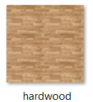**addFloor():** Utilizes **THREE.TextureLoader** [14] to load a **hardwood** **texture**, applying it to a floor mesh created with **THREE.BoxGeometry** and **THREE.MeshBasicMaterial**.

The texture is set to repeat, emulating the appearance of floor tiles. The floor mesh is then rotated and positioned to form the base of the scene.

The texture path /textures/hardwood.png

**setupControlsAndRaycaster():** Implements **OrbitControls** for interactive camera movement, allowing users to orbit, zoom, and pan around the scene. A **THREE.Raycaster** is initialized for detecting intersections with objects in the scene, enabling interactive elements to respond to user actions.

**skyShader Function**

**Adding HemisphereLight:** THREE.HemisphereLight creates a soft gradient between the sky color and the ground color, providing a natural ambient lighting effect. The first argument is the sky color, the second is the ground color, and the third is the intensity of the light.

**Adding DirectionalLight**: THREE.DirectionalLight simulates a distant light source like the sun. This light shines from a specific direction and is capable of casting shadows. Its position is set to determine the direction from which the light comes.

**Creating and Adding a Sky Object:** The Sky object is used to simulate the sky. Its size is adjusted using **scale.setScalar**. The parameters **mieCoefficient** and **mieDirectionalG** control the atmospheric scattering effects, affecting how light is dispersed in the atmosphere.

**Setting the Sun Position:** The position of the sun is determined by its elevation and azimuth angles. These angles are converted to radians and set on a **THREE.Vector3 object**. This position influences the atmospheric scattering effects and the direction of the light.

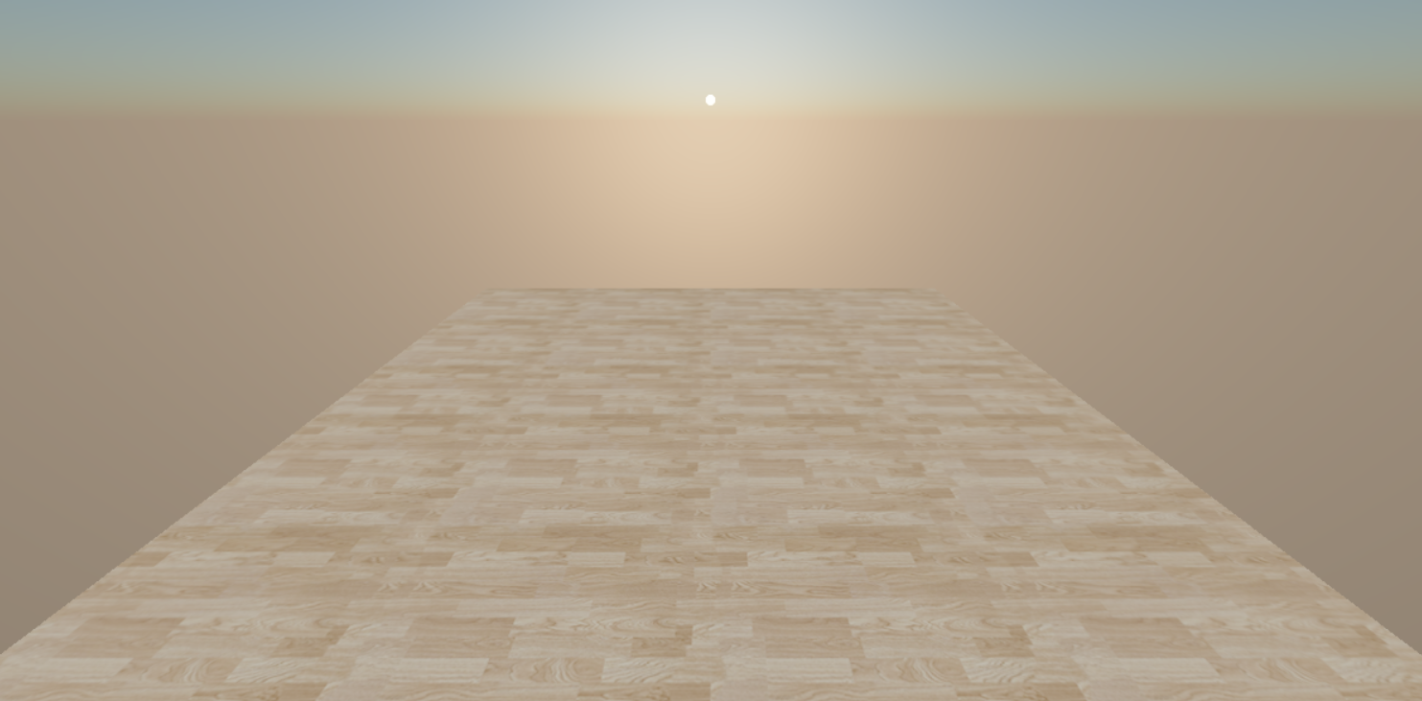

### 4.5.2. Animation and Interaction

**animate():** This function serves as the animation loop, continuously rendering the scene and updating elements based on user interaction or other dynamic factors.

It calls **requestAnimationFrame(animate)** to ensure smooth animation by syncing with the browser's refresh rate. Within the loop, the opacity of shapes intersected by the **raycaster** is adjusted, and camera controls are updated.

**adjustShapesOpacity():** Iterates through the children of a **THREE.Group** named **oneShape**, setting their material opacity to fully opaque. It then uses the **raycaster**, set to the camera's position and direction, to detect intersections with these objects.

If an intersection is found, the intersected object's material opacity is reduced, making it semi-transparent. This interaction provides visual feedback, indicating to the user that the object is interactive or has been selected.

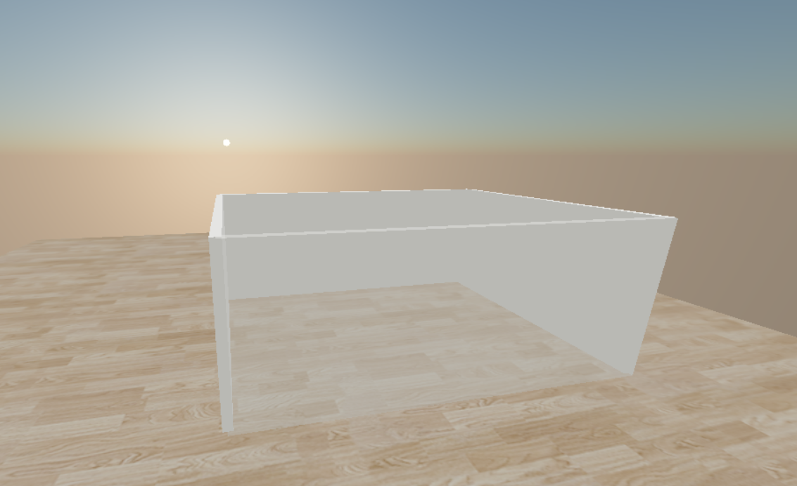

**The init function:** is responsible for initializing and setting up the scene, camera, and objects. It calls the skyShader function to add the sky and sun to the scene. Additionally, it sets up necessary lighting, the floor, camera controls, raycaster, and initiates the animation loop by calling the animate function.

### 4.5.3. Key Components and Concepts

* **Three.js Scene:** The virtual space where all 3D objects, lights, and cameras are placed. It serves as the container for the entire 3D environment.
* **Perspective Camera:** Simulates the way the human eye perceives the world, with objects appearing smaller as they get further away.
* **WebGLRenderer:** Renders the scene onto a canvas element in the web page using WebGL, a JavaScript API for rendering 2D and 3D graphics.
* **Ambient and Directional Lighting:** Creates a visually appealing and natural-looking scene by simulating both diffuse environmental light and direct sunlight.
* **OrbitControls:** Enhances user experience by allowing intuitive interaction with the 3D scene through mouse or touch gestures.
* **Raycaster:** A powerful tool for detecting intersections between a ray and objects in the scene, enabling interactive features like object selection or hover effects.

### 4.5.4. Put walls and update 3D view

how to add walls to a 3D scene and update the view dynamically using Three.js, a widely-used JavaScript library for rendering 3D graphics on the web via WebGL.

Here's a detailed explanation of how it works:

**Initial Wall Parameters**

The code starts by setting initial parameters for the walls, specifically their height (**wallHeight**) and thickness (**wallThickness**). These parameters will define the physical characteristics of the walls in the 3D scene.

**Adding a Group to the Scene**

A group [15] named **oneShape** is added to the scene. This group can contain multiple objects, allowing for collective manipulation, such as **moving** or **rotating** all included objects simultaneously.

The properties **castShadow** and **receiveShadow** are set to true for this group, enabling it to cast and receive shadows, which adds realism to the scene.

**The update3DView Function**

The main functionality for updating the 3D scene with walls is encapsulated within the update3DView function.

This function performs several key tasks:

**Clear Existing Walls:** It starts by removing the existing **oneShape** group from the scene. This is necessary to clear any previously drawn walls.A new **THREE.Group** is then instantiated and added back to the scene, providing a fresh start for drawing updated walls.

**Wall Creation Loop:** The function iterates over each shape in the shapes array. For each shape, it loops through pairs of points to construct individual walls between these points. For every pair of points (start and end), it calculates the wall's length and angle based on their coordinates.

This information is used to create a **THREE.BoxGeometry** with the specified length, thickness, and height, which represents the wall. A **THREE.MeshPhongMaterial** is applied to give the wall a solid color and allow it to interact with light sources realistically. Each wall is then positioned and rotated appropriately before being added to the **oneShape** group.

**Position and Rotation Adjustment:** After all walls are added, the entire **oneShape** group is repositioned and rotated as needed. This step is crucial for aligning the group within the scene according to the desired layout.

**Scene Redraw:** Finally, the animate function is called to render the updated scene. This function should contain the rendering logic to display the current state of the scene, incorporating any changes made by update3DView.

**Key Concepts and Components**

* **THREE.Group:** Used for grouping multiple objects together in Three.js, allowing for easier manipulation of the collection as a single entity.
* **THREE.BoxGeometry:** Represents the geometric shape of a box, used here to model the walls.
* **THREE.MeshPhongMaterial:** A material that simulates shiny surfaces with specular highlights, enhancing the visual realism of the walls.
* **THREE.Mesh:** Combines geometry with material to create a 3D object, in this case, the walls.

provides a foundation for creating and updating walls within a 3D scene using Three.js, which can be adapted and expanded for various applications, including architectural visualization.

### 4.5.5. Load furniture objects and put transformControls

how to load 3D **furniture models** into a scene using Three.js, and how to apply **TransformControls** to those objects to enable users to interactively **move**, **rotate**, or **scale** them .

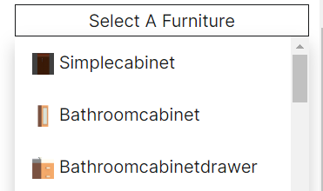**Dropdown Menu for Furniture Selection:** Uses jQuery to dynamically populate a dropdown menu with furniture items, each associated with a 3D model. Each item in the dropdown is created with an <a> tag, containing an image and the furniture's name. The click event listener attached to each item calls the loadModel function with the item's model path when clicked.

|  |
| --- |
| $(document).ready(function () {  *// Fill the dropdown menu with items.*      items.forEach((*item*) => {  *// Create a dropdown item with an image and name.*          const dropdownItem = $('<a>', {              href: '#',              html: `<img src='${*item*.image}' style='width:20px;height:20px;'> ${*item*.name}`,              click: function () {  *// console.log(item);*                  loadModel(*item*.model); *// Load the model when an item is clicked.*                  return false; *// Prevent default link behavior.*              }          });  . . . . .  }); |

**Loading 3D Models:** Utilizes the GLTFLoader to asynchronously load 3D models based on the selected item. Upon loading, each model is added to a THREE.Group to manage them as a single entity, allowing for easier manipulation (scaling, rotation, and position adjustments).

we've successfully integrated a comprehensive library of **142 .glb (GL Transmission Format) model files**, each representing a unique piece of **furniture**.

|  |
| --- |
| function loadModel(*modelPath*) {  *// Use GLTFLoader to load the 3D model.*      const loader = new GLTFLoader();      loader.load(*modelPath*, function (*glb*) {          const oneFurniture = new THREE.Group();  *. . . .*              oneFurniture.add(child);          }  *// Add the furniture object to the scene and the array for tracking.*          scene.add(oneFurniture);  *// console.log(oneFurniture);*          furnitureObjects.push(oneFurniture);  *. . . .*      });  } |

* **GLTFLoader:** Uses the GLTFLoader to asynchronously load the 3D model from the provided path. Once loaded, the model (referred to as glb) is processed.
* **Creating a Group:** A new THREE.Group instance is created to contain all parts of the loaded model. This grouping allows for easier manipulation (e.g., moving, scaling) of the entire model as a single entity.
* **Shadow Casting and Receiving:** The code iterates over all children of the loaded model, enabling them to cast and receive shadows. This enhances the realism of the scene.
* **Adding the Model to the Scene:** The group containing the model is added to the scene and the furnitureObjects array for tracking.

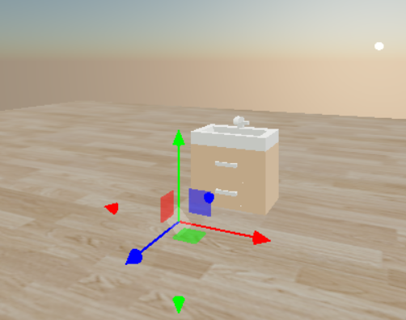**Applying TransformControls:** For each loaded furniture model, TransformControls is instantiated and attached. This enables interactive manipulation of the models within the scene. Listeners are added to handle changes and ensure the scene updates appropriately when transformations occur.

**Managing Multiple TransformControls:** An array, transform Controls List, is maintained to keep track of all TransformControls instances.

**Event Listeners for TransformControls:** Listeners are attached to handle changes (updating the scene rendering as the user manipulates the model) and to toggle the orbit controls' enabled state to prevent conflicting interactions.

### 4.5.6. Transform Controls

enabling users to control object transformations through keyboard inputs. It listens for specific key presses and adjusts the behavior of multiple TransformControls instances accordingly.

Here is a breakdown of its functionality:

* 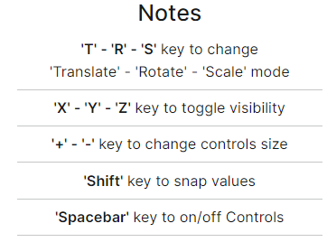**Keydown Event Listener:** registers when a user presses a key and executes corresponding actions based on the pressed key's code. These actions include setting the mode of TransformControls (translate, rotate, scale), toggling the visibility of object axes (X, Y, Z), adjusting the size of the controls, and enabling or disabling the controls.
* **Keyup Event Listener:** This listens for when the user releases a key, specifically the 'Shift' key in this context. Releasing the 'Shift' key resets the snap values for translation, rotation, and scaling to null, which were set to specific values while the key was pressed.

**Detailed Functionality for Each Key**

**T (Code 84):** Changes all TransformControls instances to **'translate'** mode, allowing for object movement.

**R (Code 82):** Switches all instances to **'rotate'** mode for object rotation.

**S (Code 83):** Sets all instances to 'scale' mode, enabling object **scaling**.

**X, Y, Z (Codes 88, 89, 90):** Toggles the visibility of the respective axis for all TransformControls instances, providing a way to focus on transformations along specific axes.

**Shift (Code 16):** While pressed, it sets specific snap values for translation, rotation, and scaling, which helps in aligning objects with precision. Releasing this key resets the snap values.

**+ or =, - or _ (Codes 187/107, 189/109):** Incrementally increases or decreases the size of the TransformControls, allowing for finer control or broader manipulation.

**Spacebar (Code 32):** Toggles the enabled state of all TransformControls instances, providing a quick way to enable or disable object manipulation.

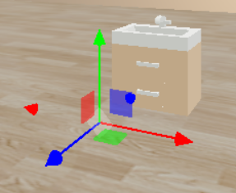 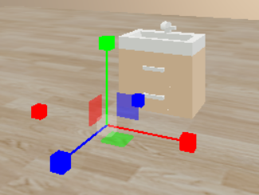 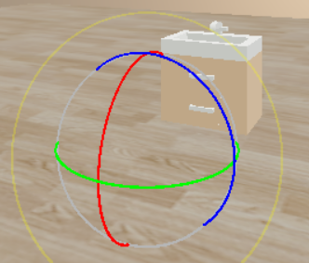

**Translate Scaling Rotate**

### 4.5.7. Drag Controls

manage drag-and-drop functionality for objects within a 3D scene. Here's a breakdown of its purpose and functionality:

**dragControlsList Array:** This array is used to store instances of DragControls. Each instance corresponds to a draggable object in the scene. The array facilitates easy access to all DragControls instances for management purposes, such as disposal.

**updateDragControls Function:** is responsible for updating the drag functionality of each object in the scene. The function performs several key actions:

* Configuration for Group Dragging: By setting the transformGroup property of each DragControls instance to true, the functionality allows for the dragging of an entire group of objects, if the object is part of a group.
* Handling of Orbit Controls: The function adds event listeners for dragstart and dragend events on each DragControls instance. When dragging starts, orbit controls (used for camera movement) are disabled to prevent unintended camera movement. Once dragging ends, orbit controls are re-enabled, allowing the camera to move again.

## 4.6. Buttons

deals with toggling between 2D and 3D views in a web-based application, adjusting the visibility of related buttons based on the user's selection, and includes functionality for resetting the camera position and rotation to its default state, saving and loading a 3D view, which.

Here's a breakdown of its purpose and functionality:

### 4.6.1. 2D and 3D View Toggle Buttons

**Functionality:** Adjusts the visibility of related buttons when toggling between 2D and 3D views.

**Implementation:**

* Within the 'DOMContentLoaded' event listener, arrays of button IDs related to 2D and 3D views are defined.
* The toggleButtonVisibility function either shows or hides specific buttons.
* Clicking the 'D2Button' will show the 3D related buttons and hide the 2D related buttons.
* Clicking the 'D3Button' will show the 2D related buttons and hide the 3D related buttons.

### 4.6.2. 2D View Button

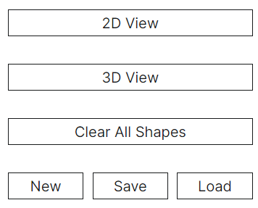**Functionality:** Switches to the 2D view.

**Implementation:** On clicking the 'D2Button', the 3D renderer is hidden, and the 2D canvas is made visible.

### 4.6.3. 3D View Button

**Functionality:** Switches to the 3D view.

**Implementation:** On clicking the 'D3Button', the 2D canvas is hidden, and the 3D renderer is made visible. Additionally, the 3D view is updated.

### 4.6.4. Reset Camera Button

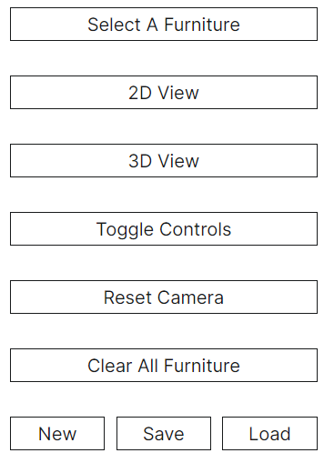**Functionality:** Resets the camera's position and rotation to its initial state.

**Implementation:**

* Stores the initial position and rotation values of the camera.
* On clicking the 'resetCamera' button, the camera's position and rotation are reset to their initial states.
* Updates the camera's projection matrix.

Window Resize Event Listener

**Functionality:** Updates the camera's aspect ratio and the renderer's size when the browser window is resized.

**Implementation:** Utilizes the 'resize' event listener to perform necessary updates whenever the window size changes.

### 4.6.5. Clear All Shapes Button

**Functionality:** Clears all drawn shapes from a 2D canvas.

**Implementation:** It accomplishes this by:

* Clearing the canvas using context.clearRect.
* Saving the drawing context's state.
* Redrawing any background elements (e.g., a grid) with drawGrid().
* Resetting the shapes array to remove all references to previously drawn shapes and starting fresh with an empty array or a new group of shapes.
* Updating the 3D view to reflect these changes with update3DView().

### 4.6.6. Clear All Furniture Button

**Functionality:** Removes all furniture objects from a 3D scene.

**Implementation:** It does so by:

* Iterating through and removing each furniture object from the scene.
* Removing associated TransformControls to prevent interaction with now-nonexistent objects.
* Disposing of DragControls instances related to these objects.
* Resetting relevant arrays (furnitureObjects, transformControlsList, dragControlsList) to their initial states.
* Refreshing the display with animate() to reflect these changes.

### 4.6.7. New One Button

**Functionality:** Combines the functionalities of clearing both 2D shapes and 3D furniture, and also resets the camera to its default position and orientation.

**Implementation:** This comprehensive reset function:

* Clears the 2D canvas and redraws necessary background elements.
* Removes all 3D furniture objects and their associated controls.
* Resets the camera to its default position and rotation values.
* Updates the 3D view to reflect all these changes with update3DView().

### 4.6.8. Toggle Controls Button

**Functionality:** Toggles the visibility and enabled state of all TransformControls within the scene.

**Implementation:** By flipping a boolean flag (toggleTransformControlObjes), it either enables or disables all instances of TransformControls, allowing the user to show or hide object manipulation handles in the 3D view.

### 4.6.9. Save Functionality

Trigger: Activated when the user clicks the 'saveButton'.

**Process:**

* The current state of the 3D scene (scene) is serialized into a JSON object using scene.toJSON().
* Any 2D shapes (presumably stored in an array named shapes) are also serialized into a JSON string using JSON.stringify(shapes).
* These two pieces of data (representing the 3D scene and 2D view) are combined into a single JSON object.
* This combined object is then serialized into a string and stored in a Blob object, which is a file-like object of immutable, raw data.
* A temporary hyperlink (<a>) element is created programmatically, its href attribute set to the URL representing the Blob, and its download attribute set to a default filename (combinedView.json).
* This link is then programmatically "clicked", triggering the download of the serialized scene data to the user's local machine as a JSON file.

### 4.6.10. Load Functionality

**Trigger:** Activated when the user clicks the 'loadButton', which indirectly causes the hidden file input (fileInput) to be clicked, allowing the user to select a file from their local filesystem.

**Process:**

* Once a file is selected, the loadView function is called by the change event on the file input.
* The selected file is read as text using a FileReader object.
* When the file reading is complete, the JSON data is parsed back into an object.
* The 3D scene part of the data is then loaded into the application's scene using THREE.ObjectLoader(), which can parse a JSON object into a THREE.Scene.
* The 2D shapes data is parsed from its JSON string form back into an array or other suitable format for the application.
* The application would then need to re-render or update both the 3D scene and the 2D view to reflect the loaded data.

# Chapter 5

# Backend

## 5.1. Why PHP is Choice in our project?

### ****5.1.1. Web-Centric Development:****

* + **Designed for Web Development:** PHP was specifically created for building web applications and integrating with HTML, making it easy to embed PHP code within HTML files.
  + **Ease of Use:** PHP has a straightforward and easy-to-learn syntax, which can speed up development time, especially for developers with basic programming knowledge.

### 5.1.2. Wide Adoption and Support****:****

* + **Large Community:** PHP has been widely adopted and has a large community, ensuring extensive support, a wealth of tutorials, and numerous pre-built modules and libraries.
  + **Documentation:** Comprehensive documentation is available, making it easier to find solutions to common problems.

### ****5.1.3. Content Management Systems:****

* + **CMS Compatibility:** PHP powers many popular content management systems (CMS) such as WordPress, Joomla, and Drupal. If your project involves a CMS, PHP is often the best choice due to native support and extensive plugins and themes.

### ****5.1.4. Cost-Effective Hosting:****

* + **Affordable Hosting:** PHP is supported by nearly all web hosting providers, often at a lower cost compared to other backend languages. Many shared hosting plans come with PHP pre-installed, simplifying deployment.

### 5.1.5. Database Integration****:****

* + **Database Support:** PHP works well with various databases, particularly MySQL, which is also widely supported by hosting providers. It has built-in support for connecting to and interacting with databases.

### ****5.1.6. Frameworks:****

* + **Robust Frameworks:** PHP has several robust frameworks like Laravel, Symfony, and CodeIgniter that provide structure and best practices, enhancing development speed and maintainability. These frameworks come with built-in tools for routing, authentication, and database abstraction.

**Conclusion**

Given the above points, PHP is an excellent choice for projects that are web-centric, require content management, need to be cost-effective, and benefit from rapid development. If your project aligns with these criteria, PHP would be a strong candidate for the backend technology.

1. **Small to Medium Business Websites:**
   * Websites for small to medium businesses that need to be developed quickly and maintained easily can leverage PHP for its affordability and ease of use.
2. **E-commerce Platforms:**
   * PHP is well-suited for e-commerce platforms, especially when using frameworks like Laravel or content management systems like WooCommerce (built on WordPress).
3. **Blogs and News Sites:**
   * PHP is ideal for blogs and news sites due to its integration with WordPress and other CMSs, which provide extensive customization options and plugins.

By considering these factors, PHP may indeed be the best choice for your project, offering a balance of ease of development, cost-efficiency, and strong community support.

## 5.2. Connection between database and php

### 5.2.1. Choose a Database

Common databases used with PHP include MySQL, PostgreSQL, SQLite, and more. MySQL is particularly popular and will be used for this example.

### 5.2.2. Set Up the Database

Before connecting, ensure the database is set up and accessible with the necessary credentials (hostname, username, password, and database name).

### 5.2.3. Connect to the Database

#### Using MySQLi

**MySQLi (MySQL Improved)** is a PHP extension designed to work with MySQL databases. It supports both procedural and object-oriented approaches.

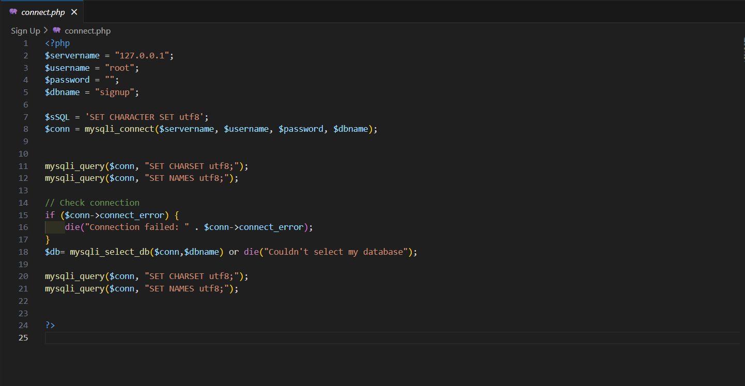

## 5.3. Create the Users Table

### 5.3.1.Ensure table in your database to store the user data.

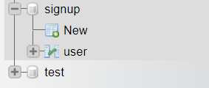

### 5.3.2. structure of table

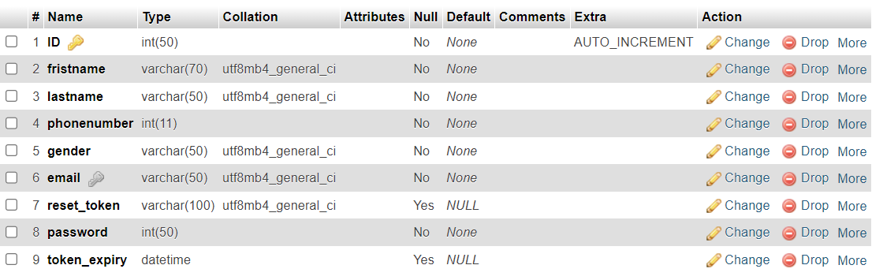

### 5.3.3.ER Schema

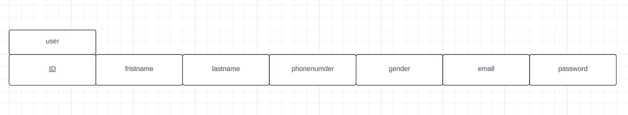

Relationships between entities in a database.

**Action of sign up**

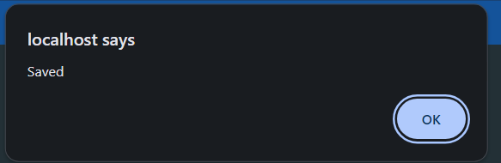

**Login**

## 5.4 Form Handling Script:

Create a login.php file to handle the form submission and validating the input, verifying the credentials against database managing user sessions .

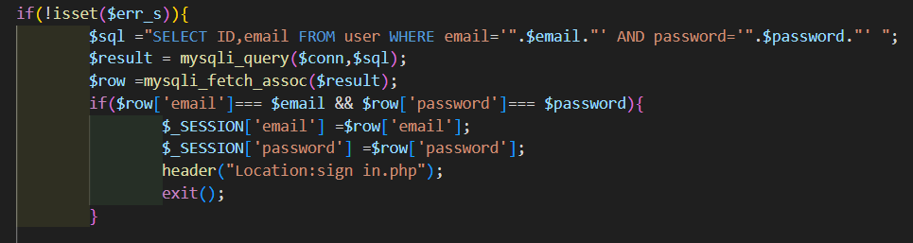

- After that go to home

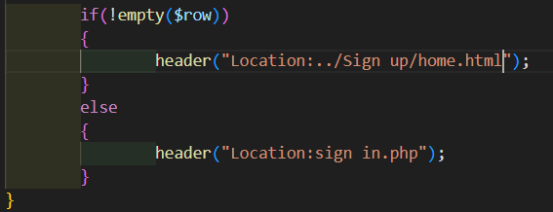

**Forget password**

## 5.4.1Handle Form Submission:



### 5.4.2.Load Composer's autoloader:

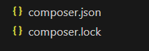



### 5.4.3.Download PHPMailer

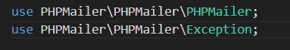

### 5.4.4. Generate forget Password

1. Check if email exists

2.Generate a secure token

3. Token expiry time

4.Save token and expiry in database

5. Send email using PHPMailer

6.Recipients

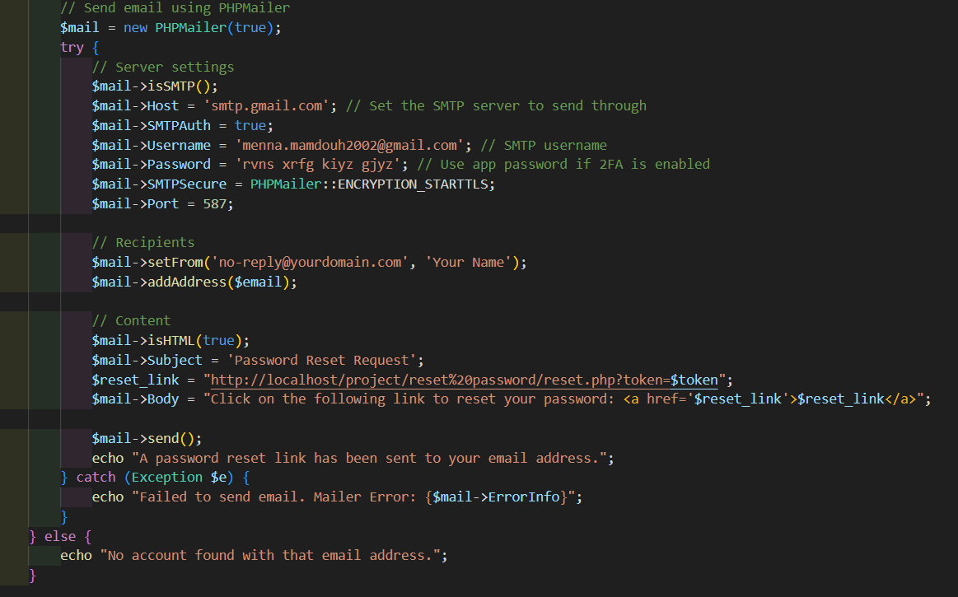

**Action of forget**

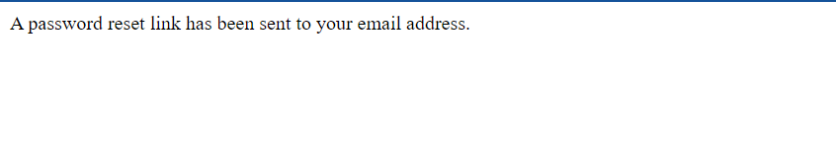

**Reset password**

1.**Generate a Password Reset Token:**

**2.Send Password Reset Email:**

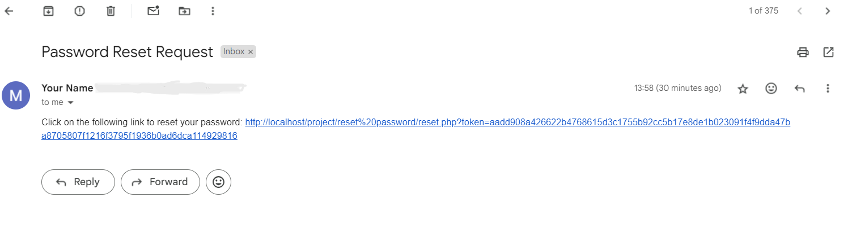

**3.Handle Password Reset Form Submission**

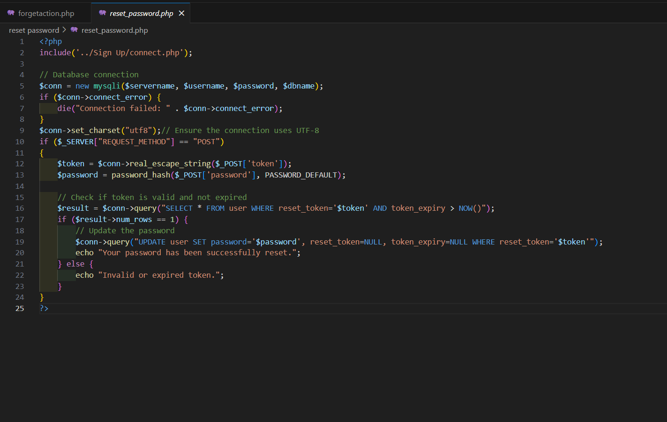

**4.Update the User's Password**



# 

# Chapter 6

# References

[1] [Three.js](https://threejs.org/docs/index.html#manual/en/introduction/Installation)

[2] [OrbitControls](https://threejs.org/docs/#examples/en/controls/OrbitControls)

[3] [Sky Shader](https://threejs.org/examples/webgl_shaders_sky.html)

[4] [GLTFLoader](https://threejs.org/docs/#examples/en/loaders/GLTFLoader)

[5] [DragControls](https://threejs.org/docs/#examples/en/controls/DragControls)

[6] [TransformControls](https://threejs.org/docs/#examples/en/controls/TransformControls)

[7] [scene](https://threejs.org/docs/#api/en/scenes/Scene)

[8] [camera](https://threejs.org/docs/#api/en/cameras/Camera)

[9] [PerspectiveCamera](https://threejs.org/docs/#api/en/cameras/PerspectiveCamera)

[10] [OrthographicCamera](https://threejs.org/docs/#api/en/cameras/OrthographicCamera)

[11] [WebGLRenderer](https://threejs.org/docs/#api/en/renderers/WebGLRenderer)

[12] [AmbientLight](https://threejs.org/docs/#api/en/lights/AmbientLight)

[13] [DirectionalLight](https://threejs.org/docs/#api/en/lights/DirectionalLight)

[14] [TextureLoader](https://threejs.org/docs/#api/en/loaders/TextureLoader)

[15] [Group](https://threejs.org/docs/#api/en/objects/Group)